# Query Profile (Hands On)

* Here, we are going to talk about query profile in Databricks. The query profile helps you troubleshoot performance bottlenecks during the query execution.
* If you click on any **table name** in the **pipeline editor**, you can explore its data, but at the bottom you can click Query Performance or go directly to the **Query Performance tab**.

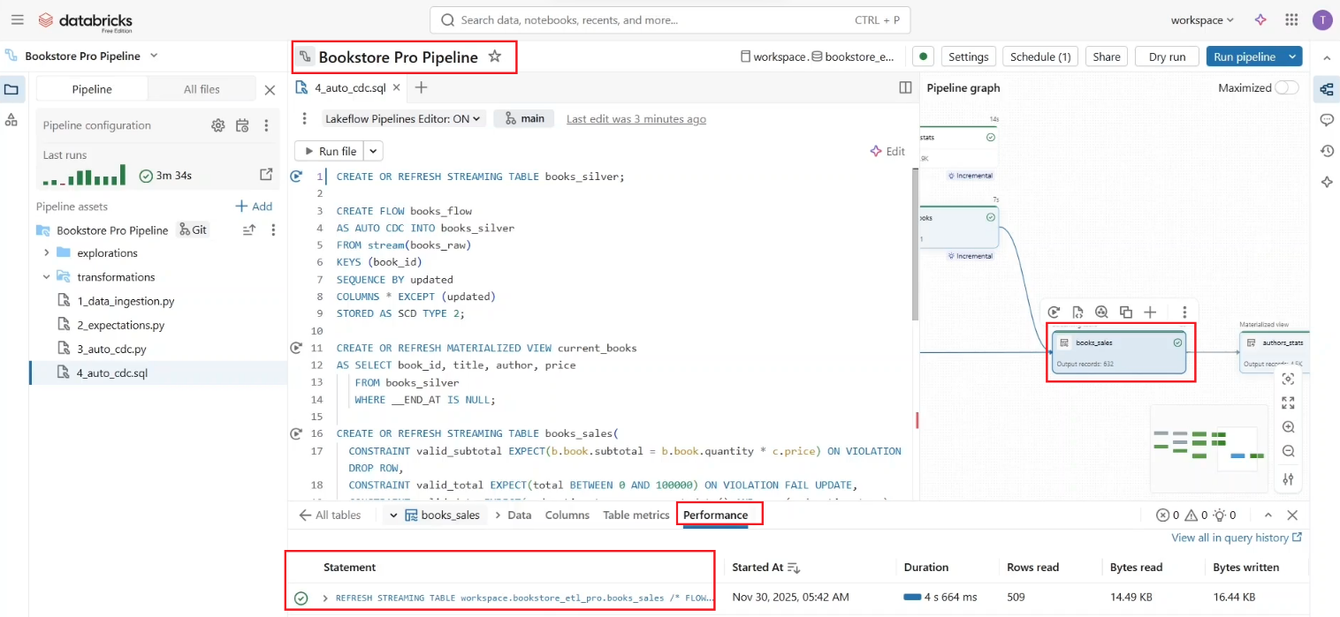

* If you click on the **query statement**. This opens the summary of the query execution, which includes **query status, query statement query metrics** including an overview of input output metrics such as the **number of read** **and written bytes, rows, and files**.

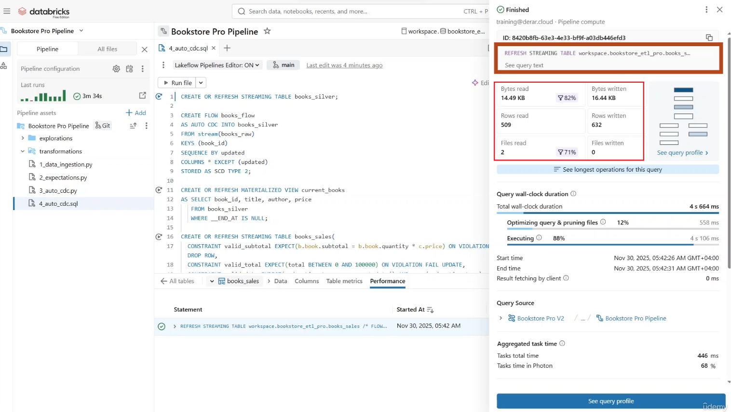

* If you scroll down, you can find more details about these metrics.

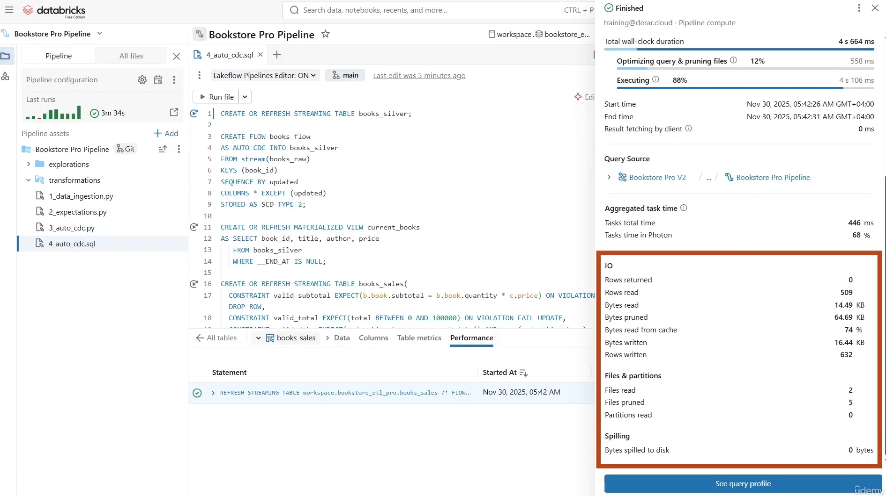

* In addition, you have time based metrics such as the **Wallclock duration** and **aggregated task time**. The Wallclock duration measures the total time from the start of the query scheduling to the end of query execution, including optimization and file pruning. As you can see in the breakdown, a 12% of the query time is spent on optimization and file pruning, while the rest on the actual execution. **Aggregated task time** shows the combined time it took to execute the query across all cores of all nodes. It can be significantly **longer** than the **wallclock duration** if multiple tasks are executed in parallel. While it can be **shorter** than the **wallclock duration** if task waited for available nodes, you can also click “**See Query Profile**” to view more details.

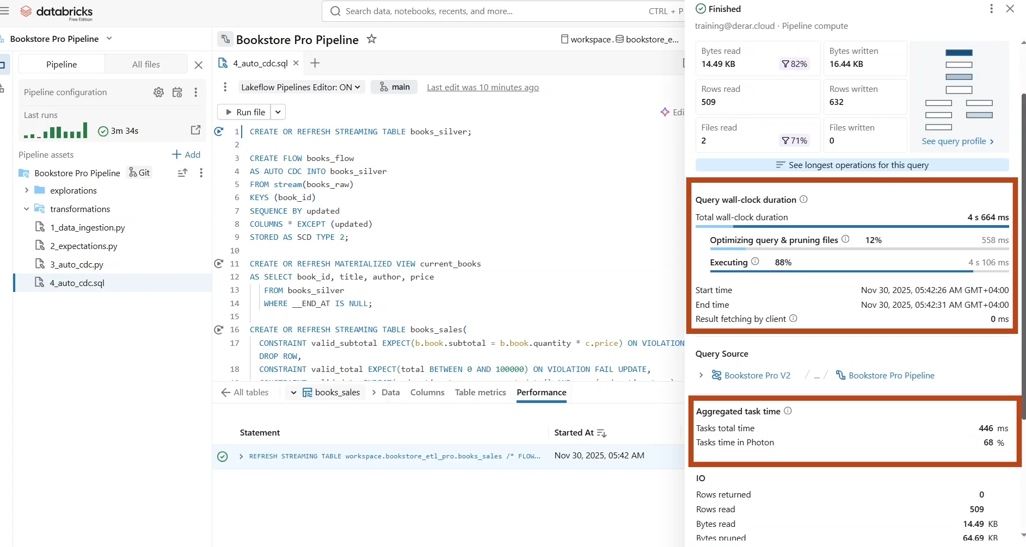

* The detailed **query profile** includes summary metrics on the left side of the panel, and the graph view of operators on the right.
  + The left side of the query profile has three tabs.
  + **Details**, that shows the summary metrics we have just explored.

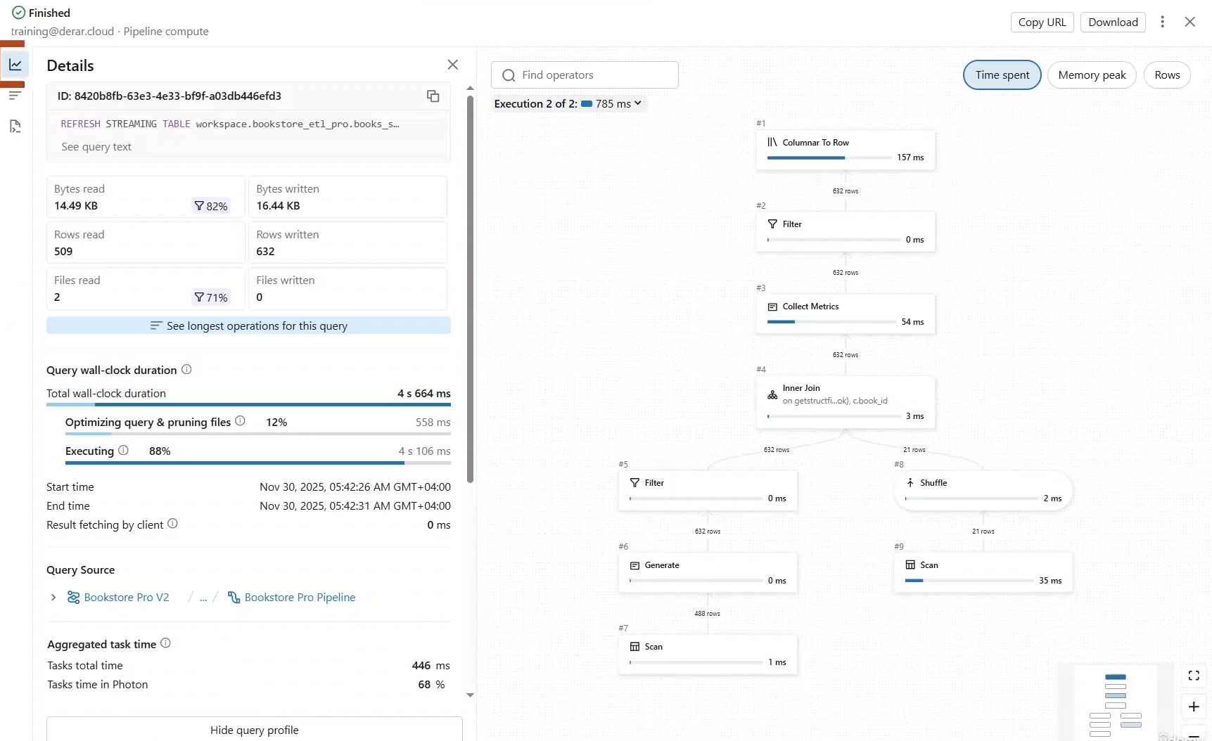

* + **Top operators**, that shows the most expensive operations used in your query in terms of time spent, memory peaks, and number of processed rows. These can be useful for identifying optimization opportunities.

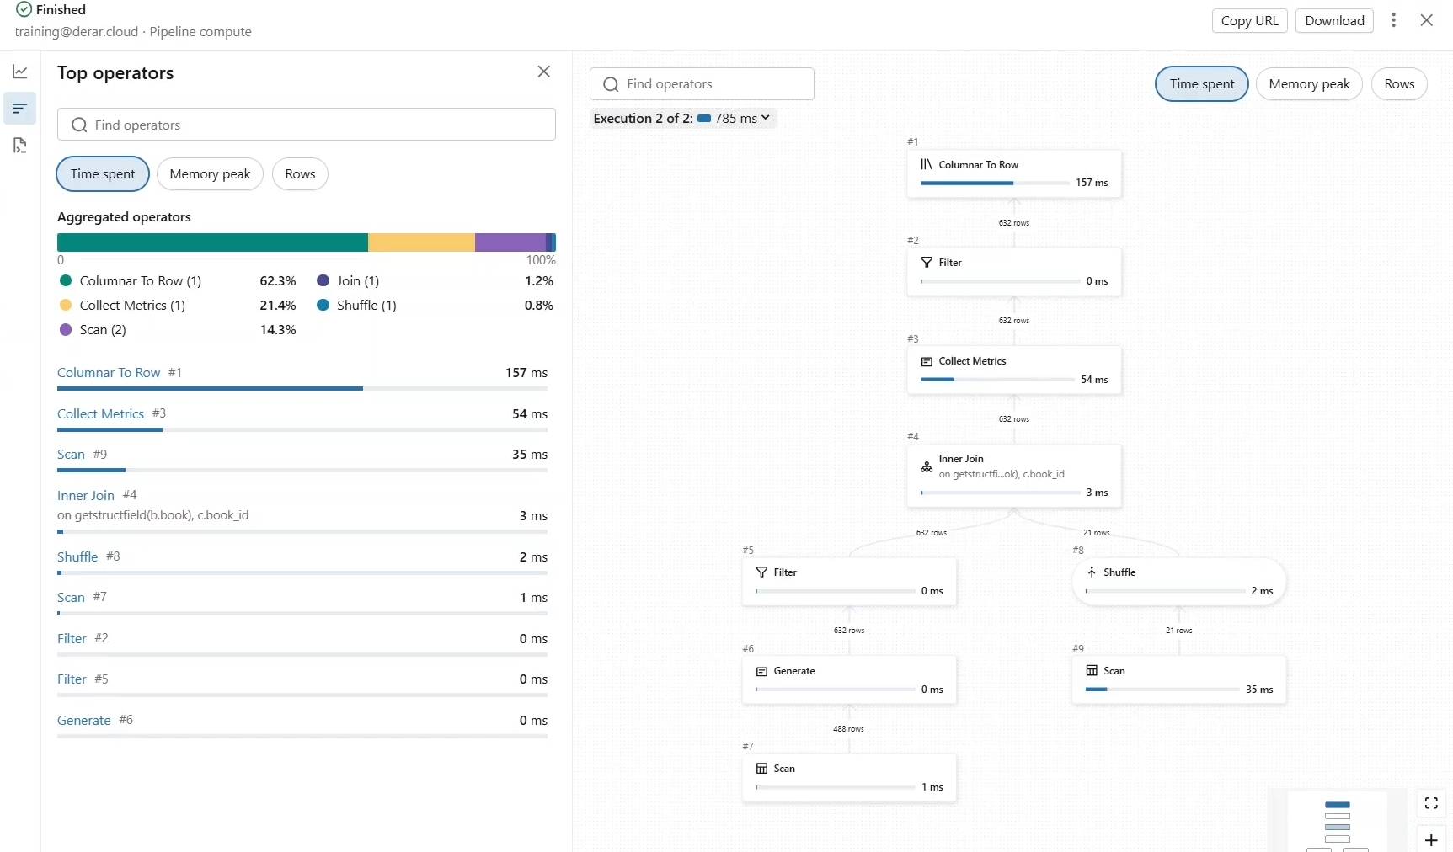

* + You can see these operators **represented as a graph** with different metrics.

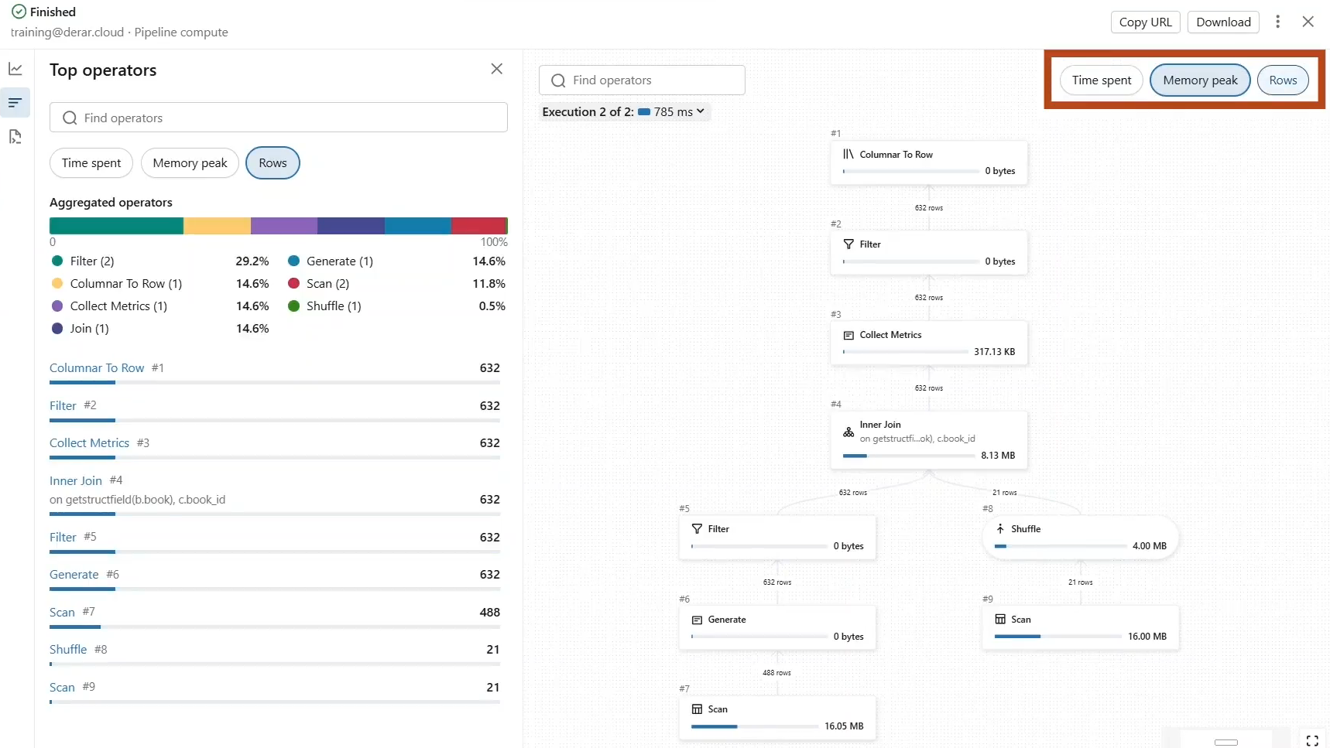

* + You can also click on any operator to show detailed metrics and descriptions. For example, this **inner join** operation is executed on the **photon engine**.

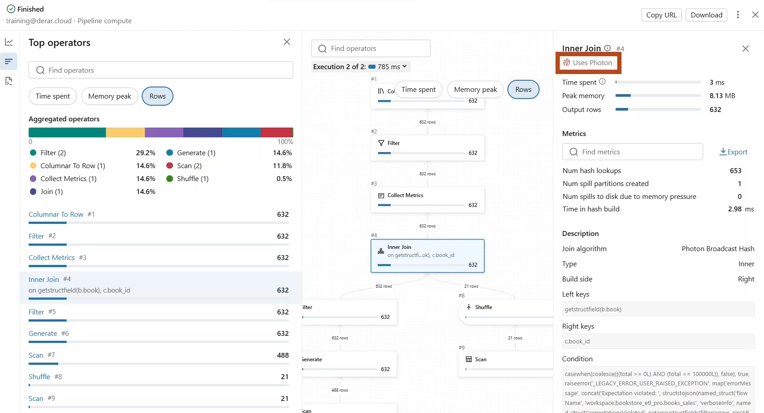

* + Lastly, we have the **Query text** tab that shows the full text of the query.

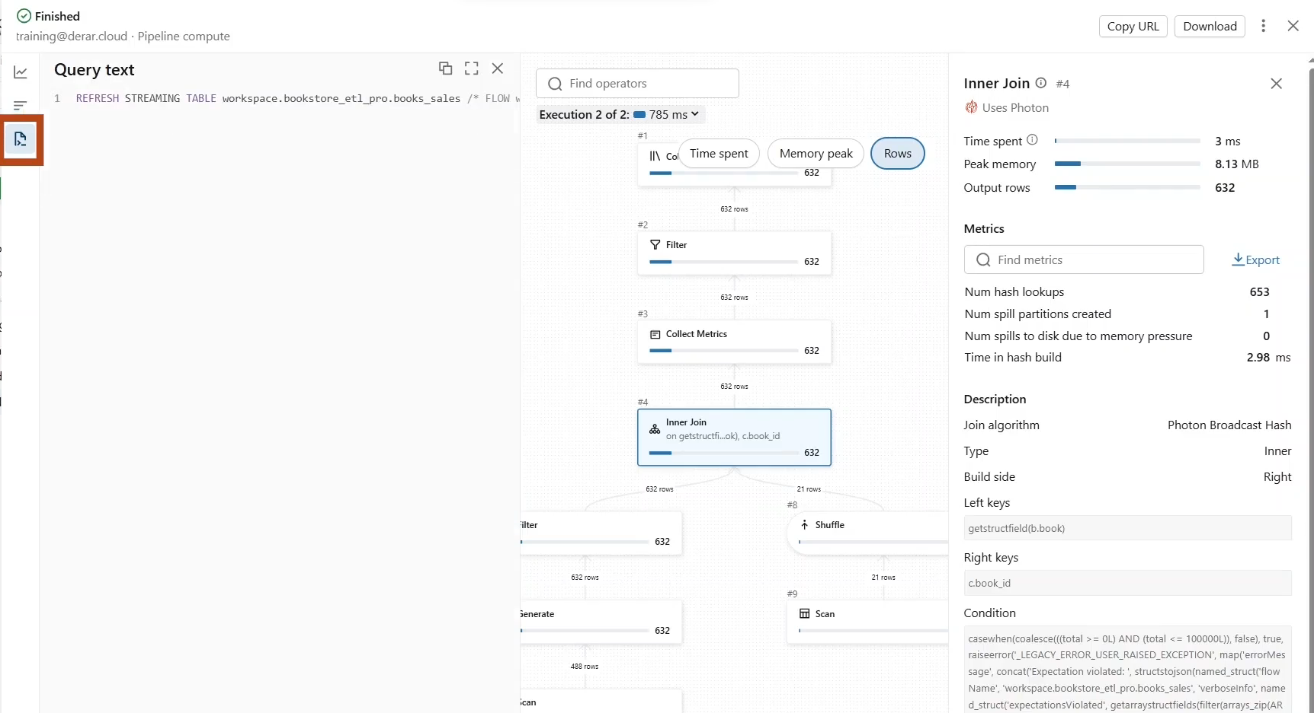

* + The **query profile** is also available for your queries in the **SQL editor** and **notebooks** as well.

**Query Profile in SQL Editor**

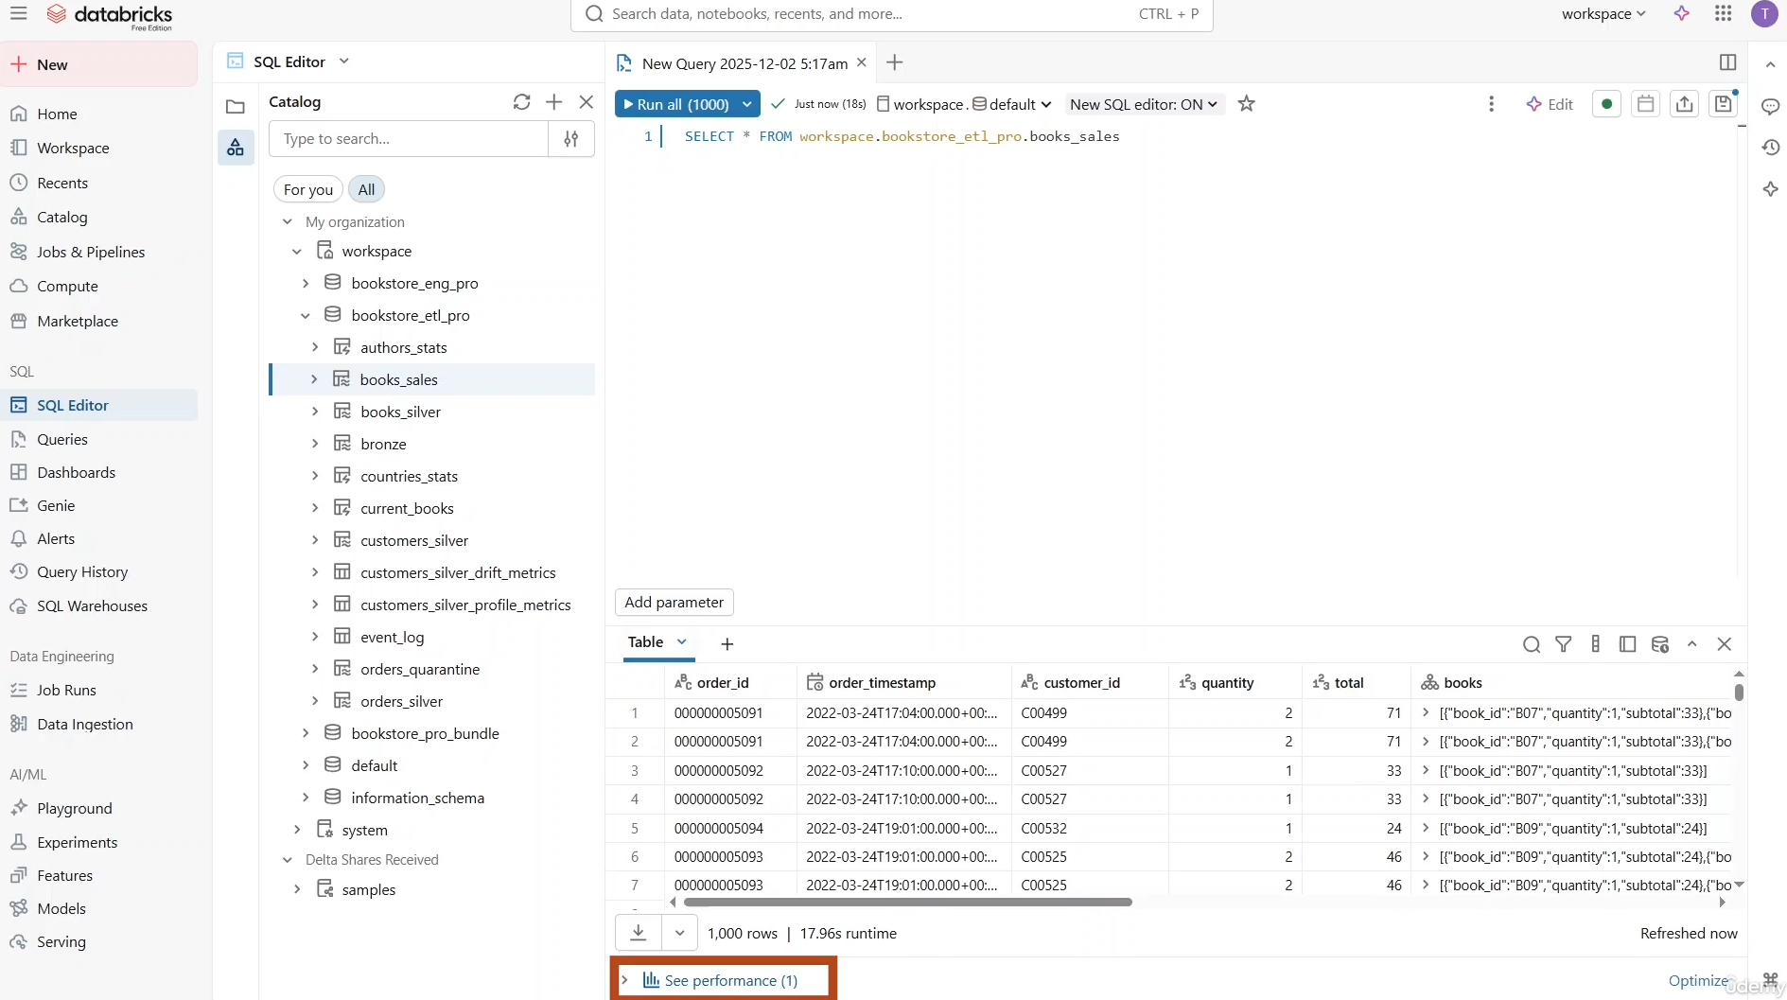

**Query Profile on Notebooks**

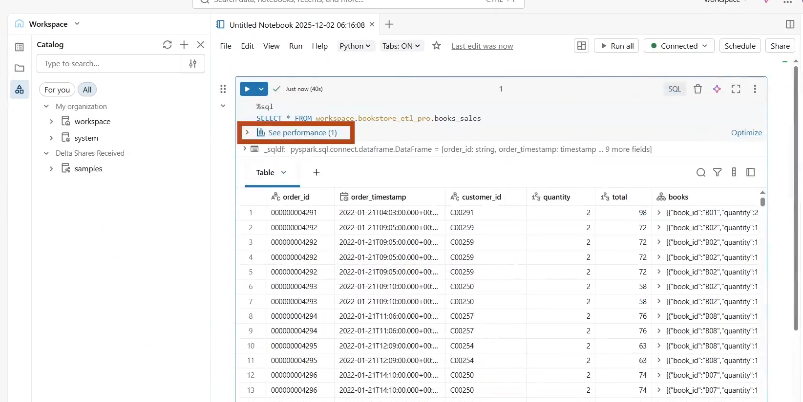

# Orchestrating LDP Pipelines (Hands On)

* Here, we will see how to schedule an ETL pipeline as part of a job and also learn some advanced job configuration.

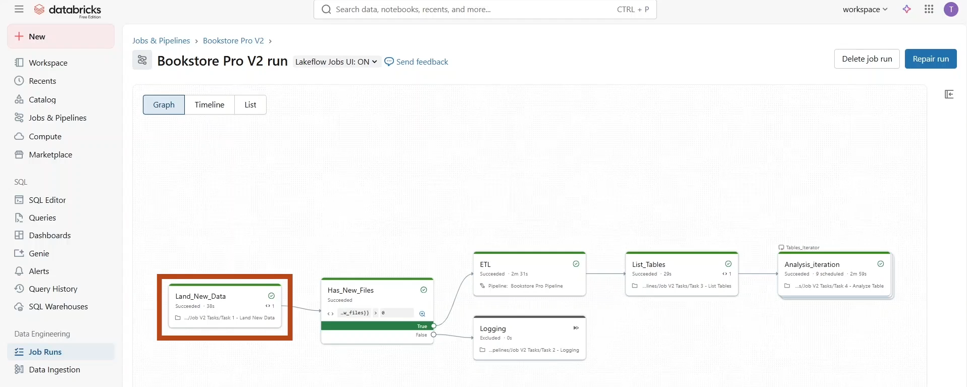

* We are going to build this job where we start by **landing a new set of data files** to be processed by our ETL pipeline.
* Next, we use an IF...ELSE... condition task to check whether any new files were added.
  + If so, we proceed to process them using our pipeline.
  + If not, we simply log that no new data is available for this run.
* Once the pipeline run completes, we dynamically list (via **List_Tables** task) all the created tables so we can perform data analysis on each table separately using a for each task (i.e. using **Analysis_iteration** task).
* To create such a job, start by navigating to “**Jobs & Pipelines**” and click **Create 🡪 Job**.

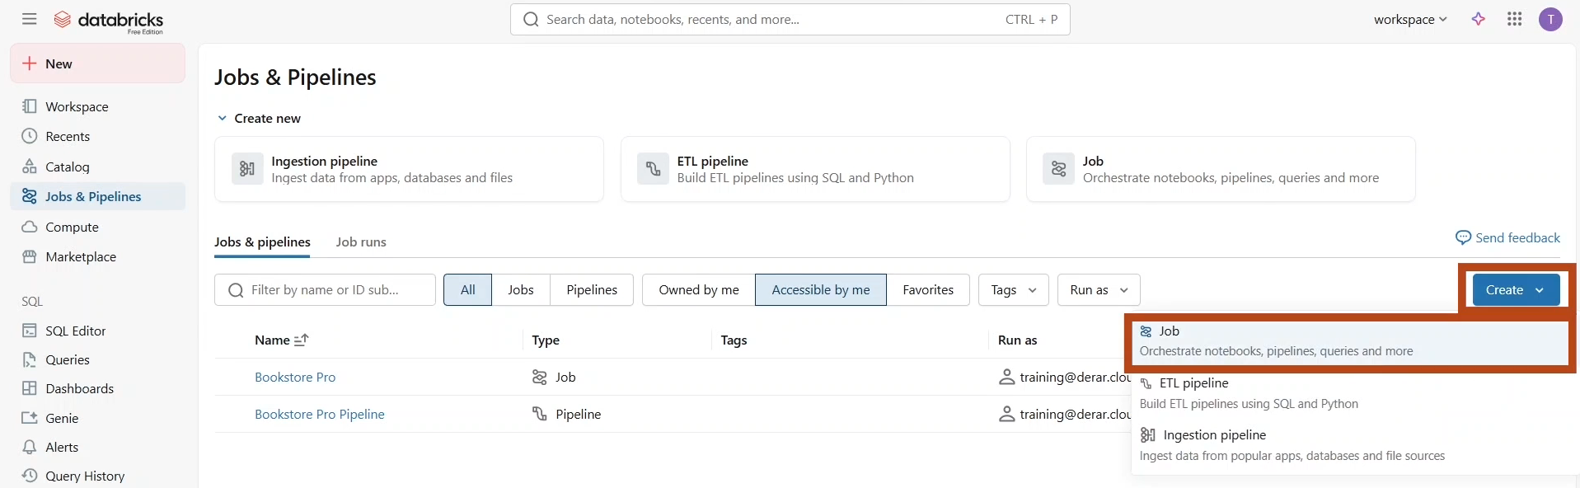

* Set the **job name** “Bookstore Pro v2” and start configuring the first task, which is a **notebook** task.

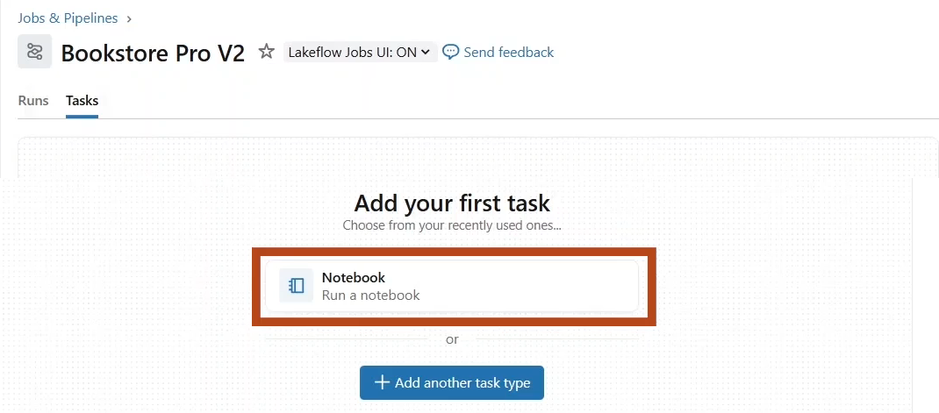

* Provide Task name as “**Land_new_data**” for Barth.
* We are going to select the notebook “**Task1 – Land New Data**” from the job v2 folder.

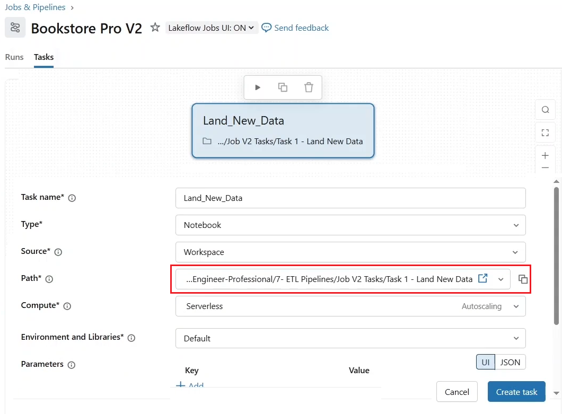

* If we take a look at this notebook. We see that it contains a call for the **load_pipeline_data** function to land the new data files in our source directory.
  + This function returns the number of landed files, which we would like to pass to other tasks in our job, especially the IF ELSE condition task.
  + To achieve this, we can use **taskValues** from **dbutils** jobs function.
  + With the set function, you can pass information between job tasks as a key value pair.
  + So here we set the number of new files as a task value.

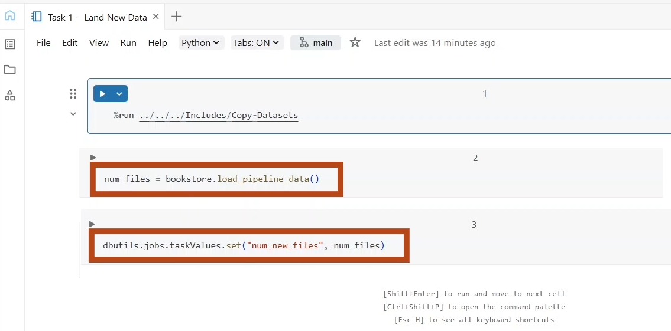

* Let us come back to our **job configuration** and see how to access this value.
  + For now, let us “**Save**” this task configuration and add a new task of type IF ELSE condition.

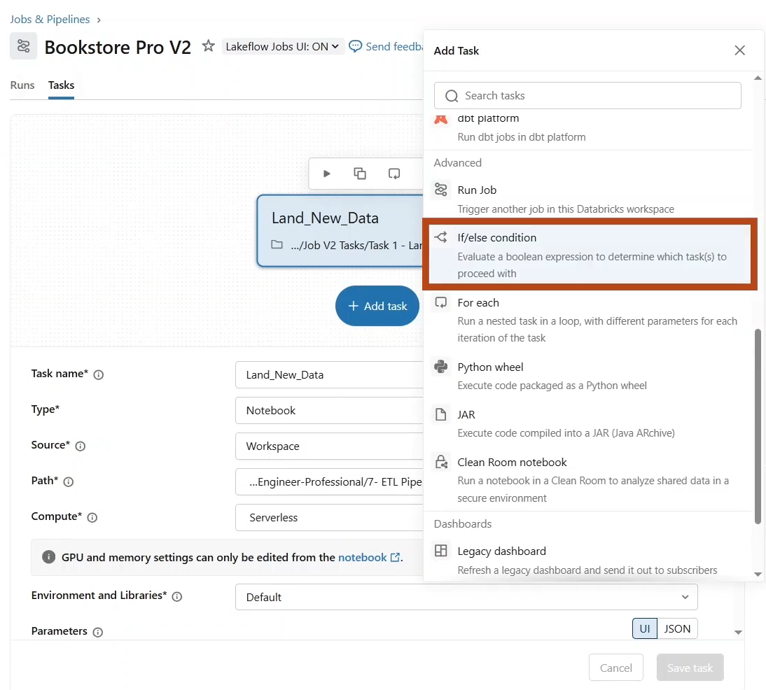

* + Task name “Has_New_Files”.
  + Next, we define the condition. You can click here to insert **dynamic value references** such as task values. As you can see, you can access several information related to the preceding task, such as its result, status, and error codes.

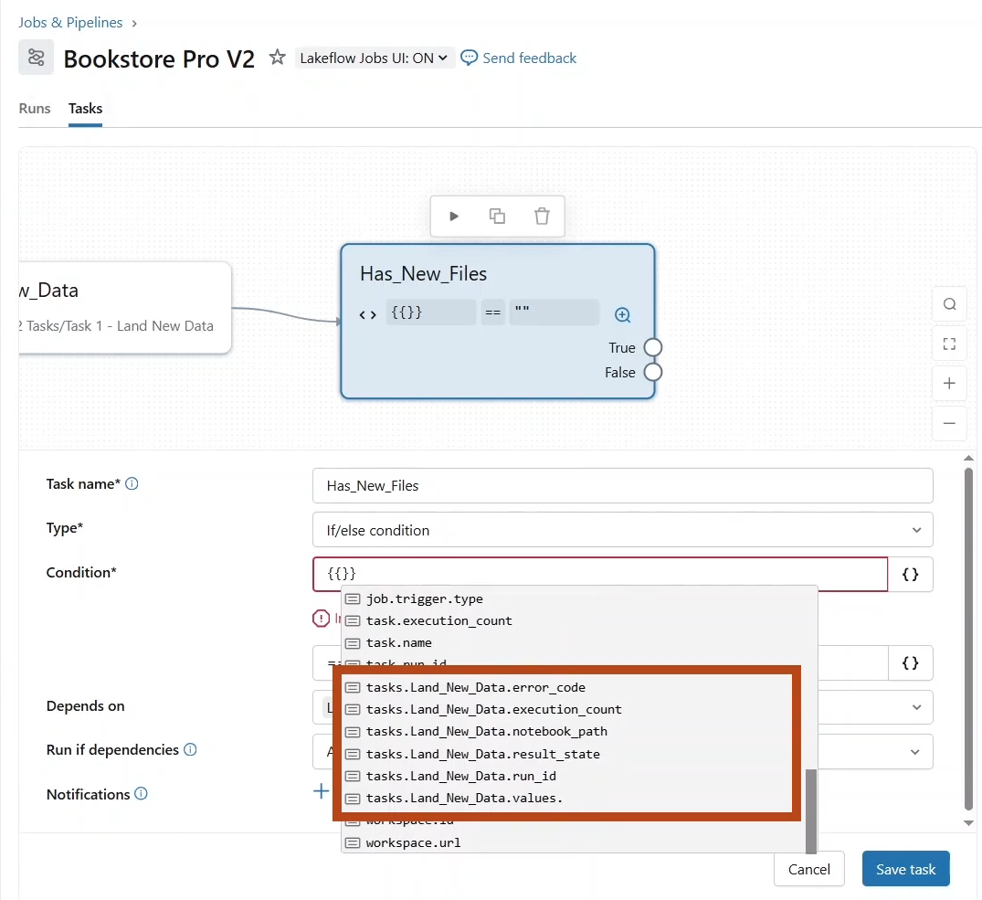

* + For task values, select **tasks.Land_New_Data.values** and type the key – “**num_new _files**”. This value should be greater than zero.
  + Notice that you can also define a condition based on job level references, such as the job starting day and hour, or the weekday variable, which returns true if the job starts on a weekday.
  + Keep in mind that all time based references here are in the UTC time zone.

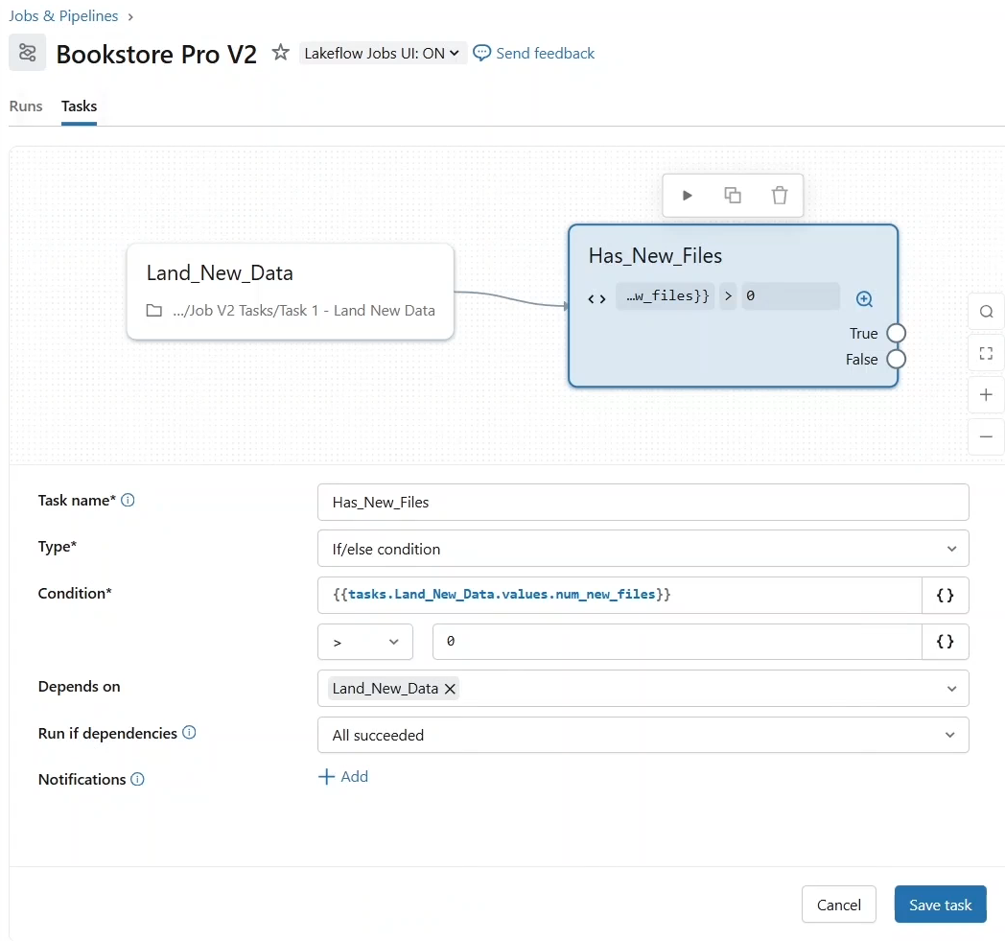

* + Let us **save** the task.
* Next, add a task of type **ETL pipeline** to trigger an update of our LDP pipeline.

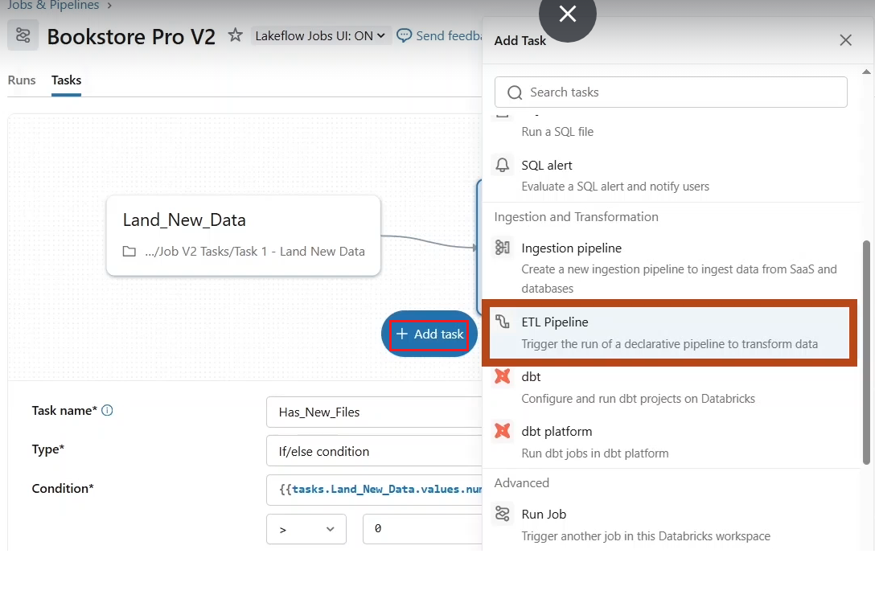

* + Give Task name as **ETL**
  + For pipeline, we choose our **Bookstore Pro pipeline** previously created.

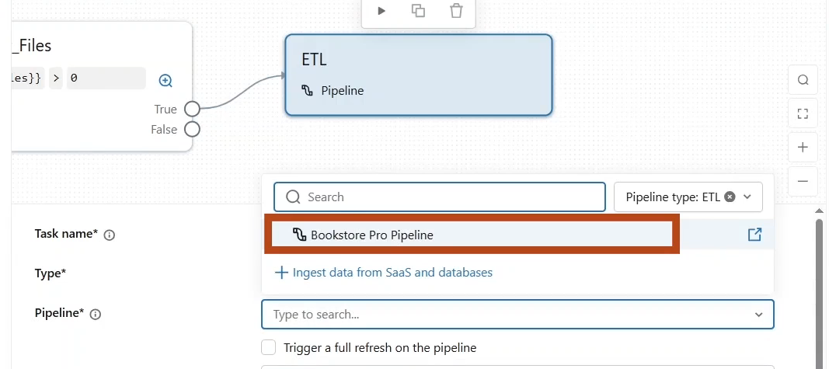

* + That **depends on** field default to the previously defined IF ELSE task.
  + However, notice that you have the option to run this task on the true or false condition evaluation.

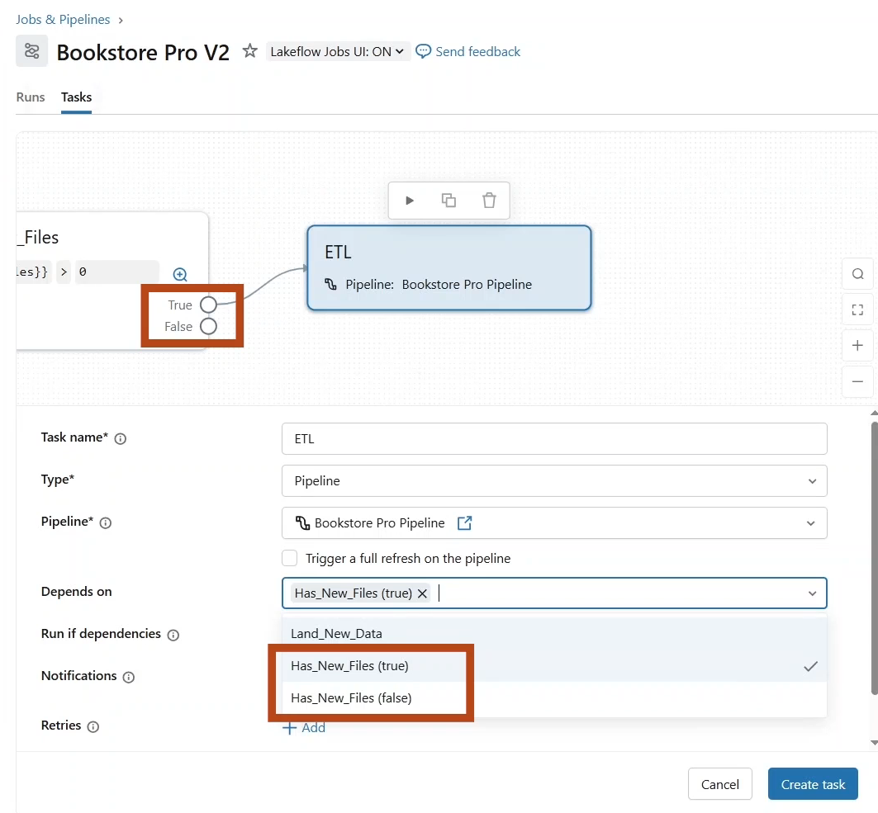

* + Let us proceed with the true branch and click **save** task.

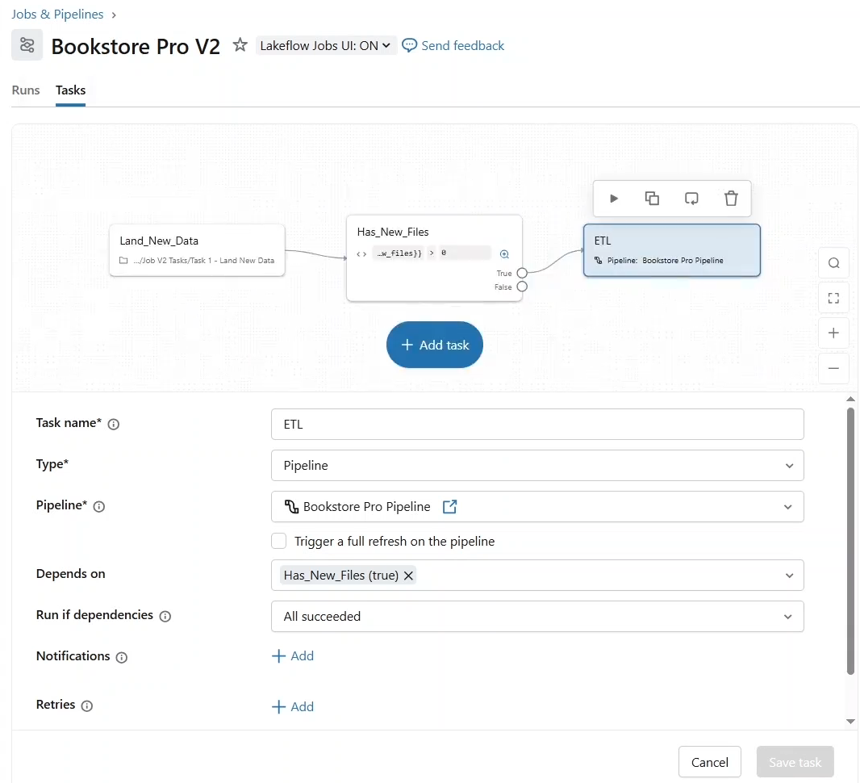

* On the First branch, we will just add a **notebook task** to log this outcome.

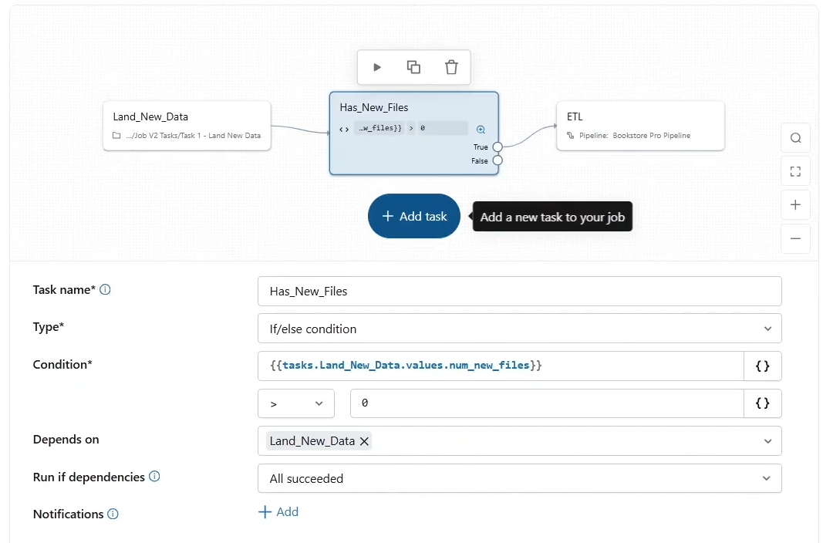

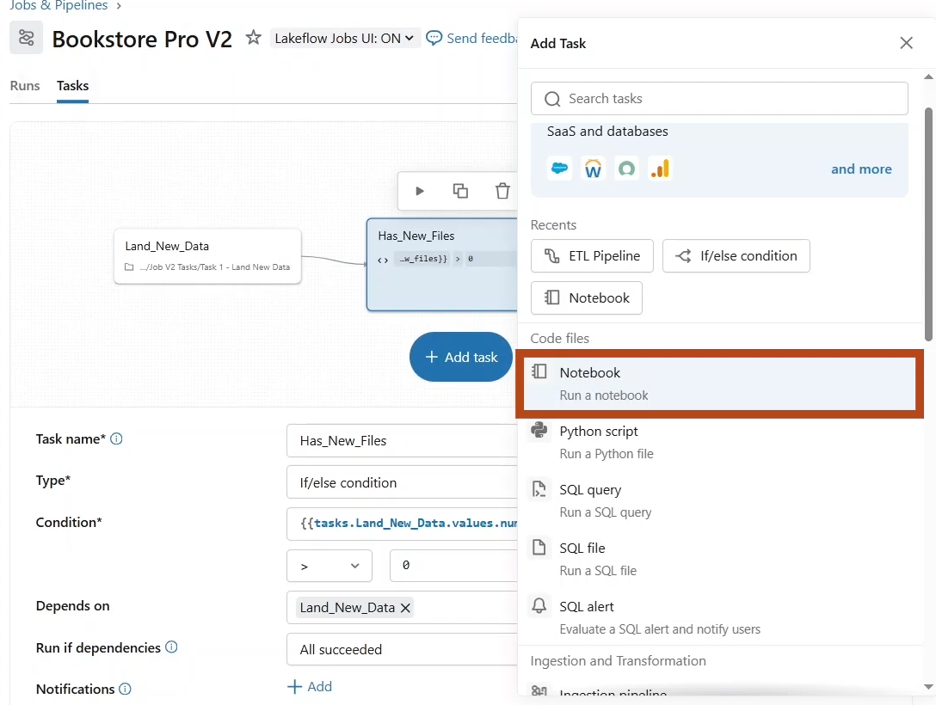

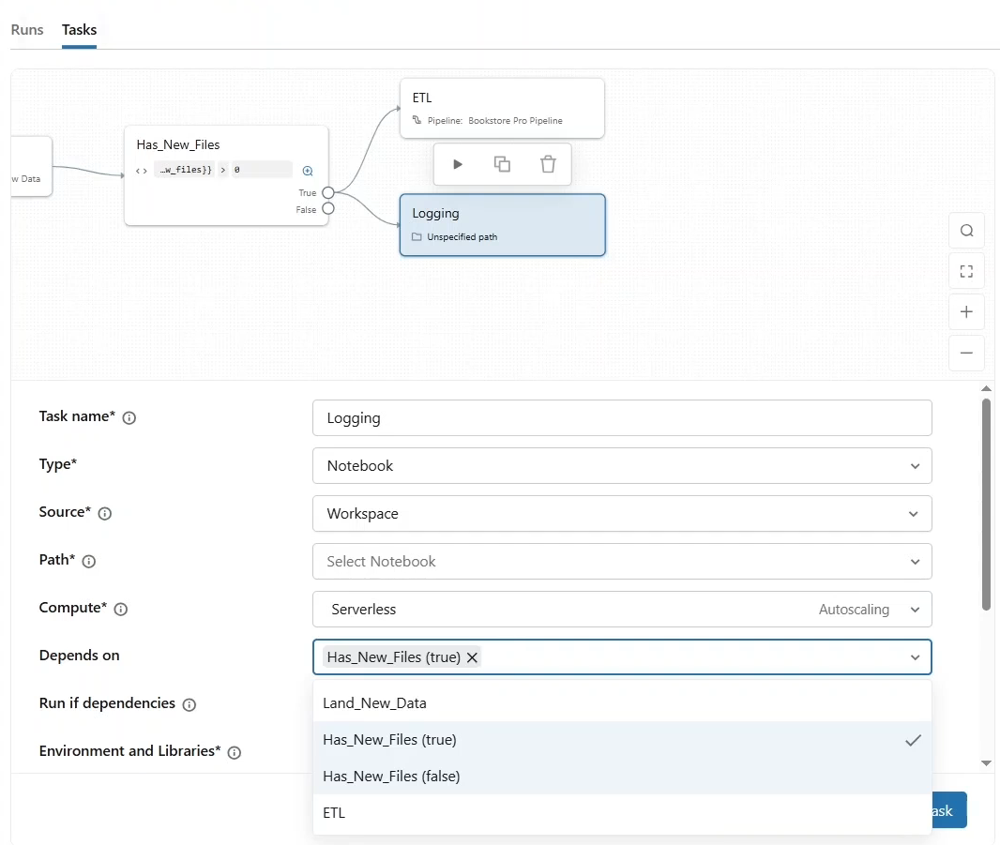

* + For the **depends on** field, choose the false branch of our IF ELSE condition task.

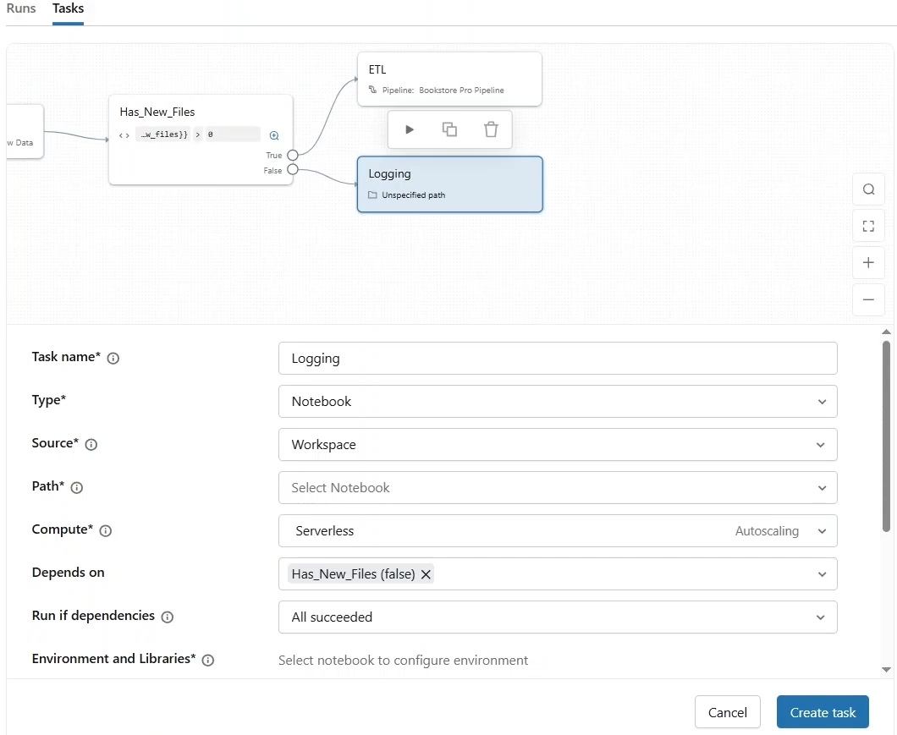

* + For **path**, we are going to select the **logging notebook** from the **Job V2 Tasks** folder.

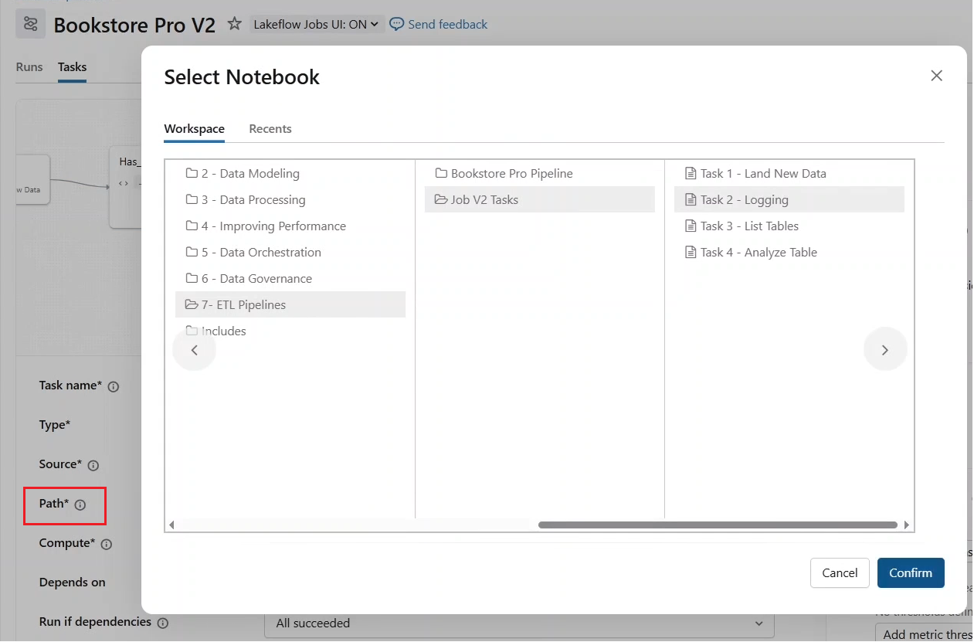

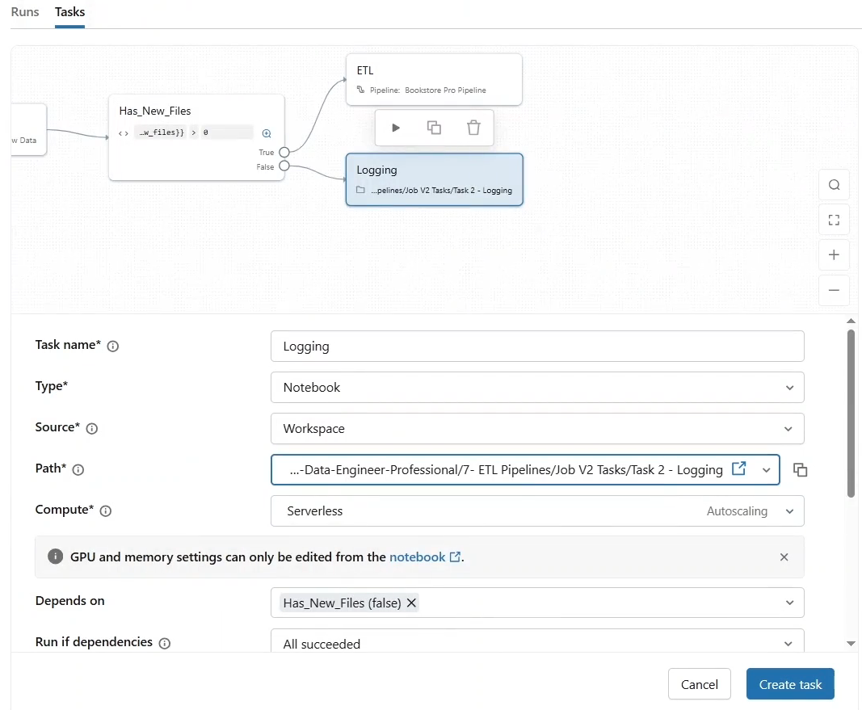

* Let us look at this notebook. For simplicity, this notebook just prints a message with task parameters such as job ID and job starting time.

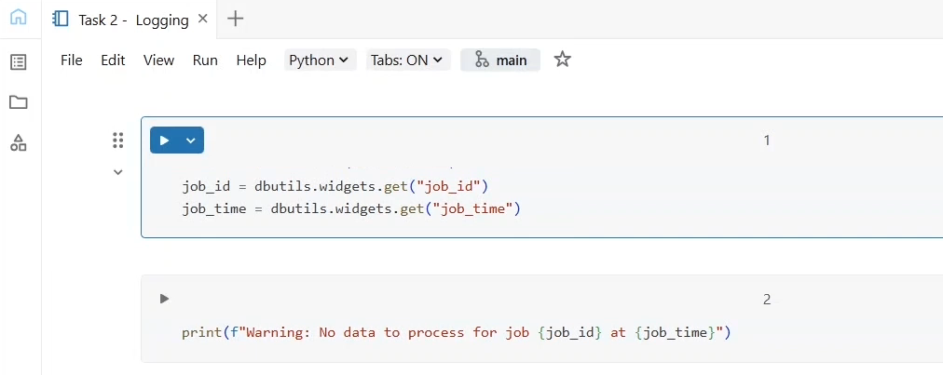

* Let us pass these parameters from the task configuration. Under **parameters**. Let us add the first parameter **job id**, which will be resolved from the **dynamic value reference** job.id, as you can see, other references are available for you, such as job name, repair counts and run ID depending on your business needs.

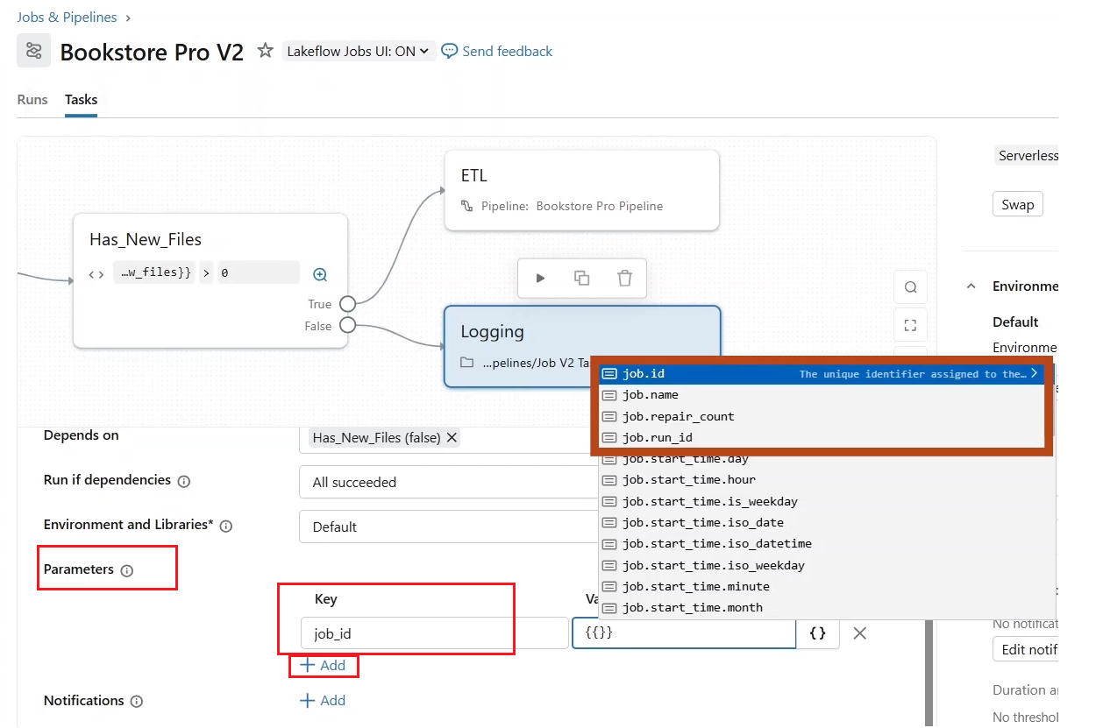

* Let us add the **second parameter** for the job starting time “job_time”. Notice that all time-based references here are in the UTC time zone. Let us choose ISO date time for this parameter, which resolves to the date and time in ISO format.

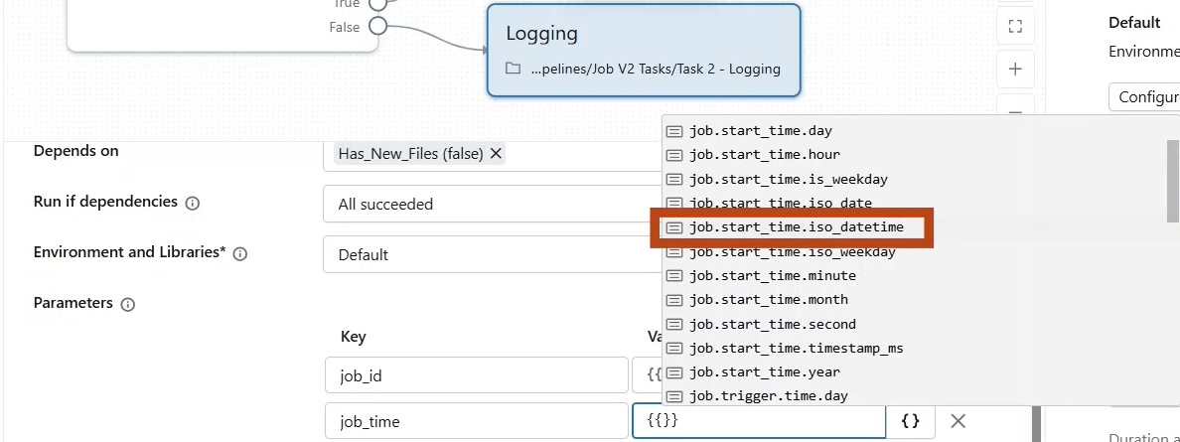

* Also, let us set the **task level notification** to be notified by email if this task has succeeded. This will help us keep informed if there is no data to process.

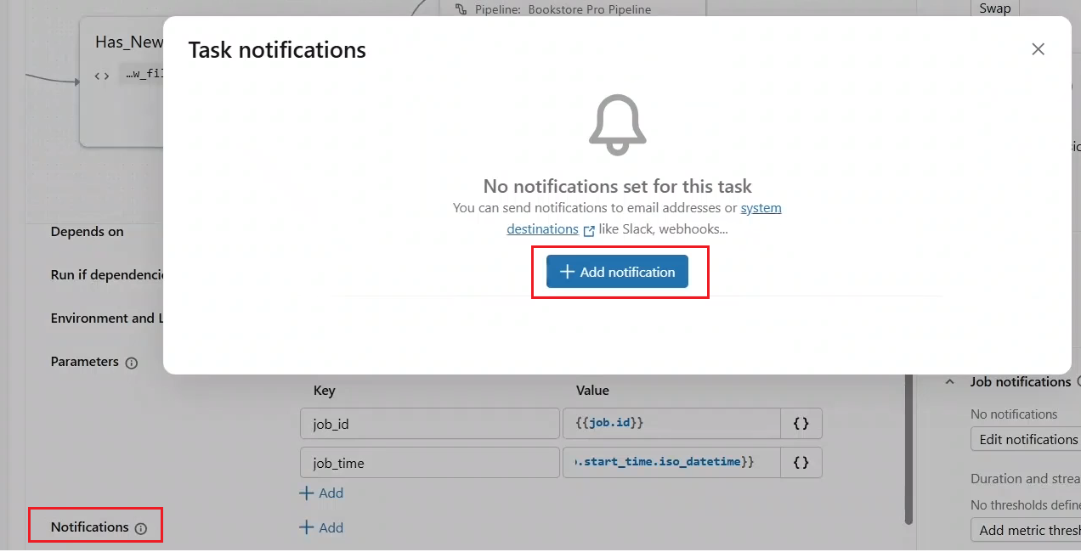

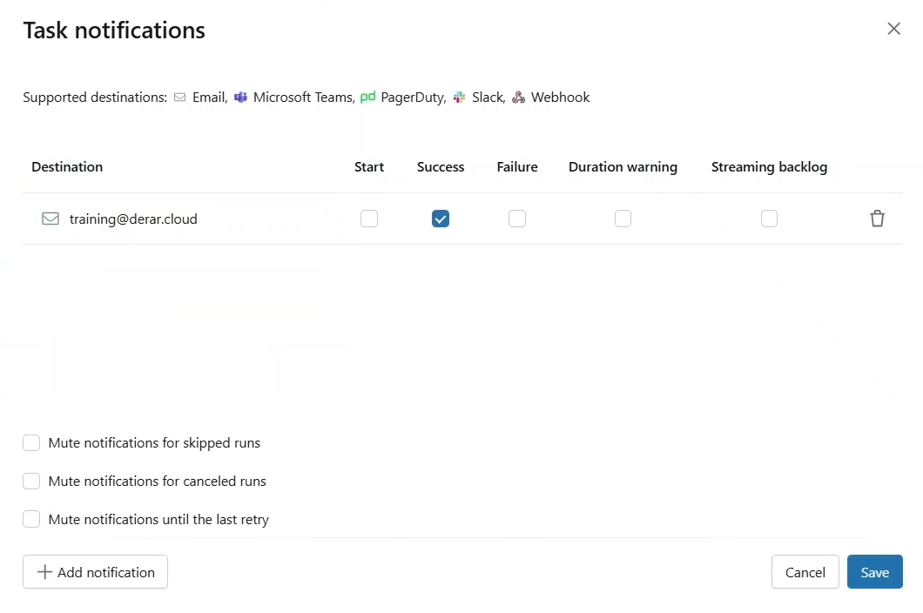

* Remember, task notifications are different from job notifications, which are triggered when the entire job succeeds or fails.

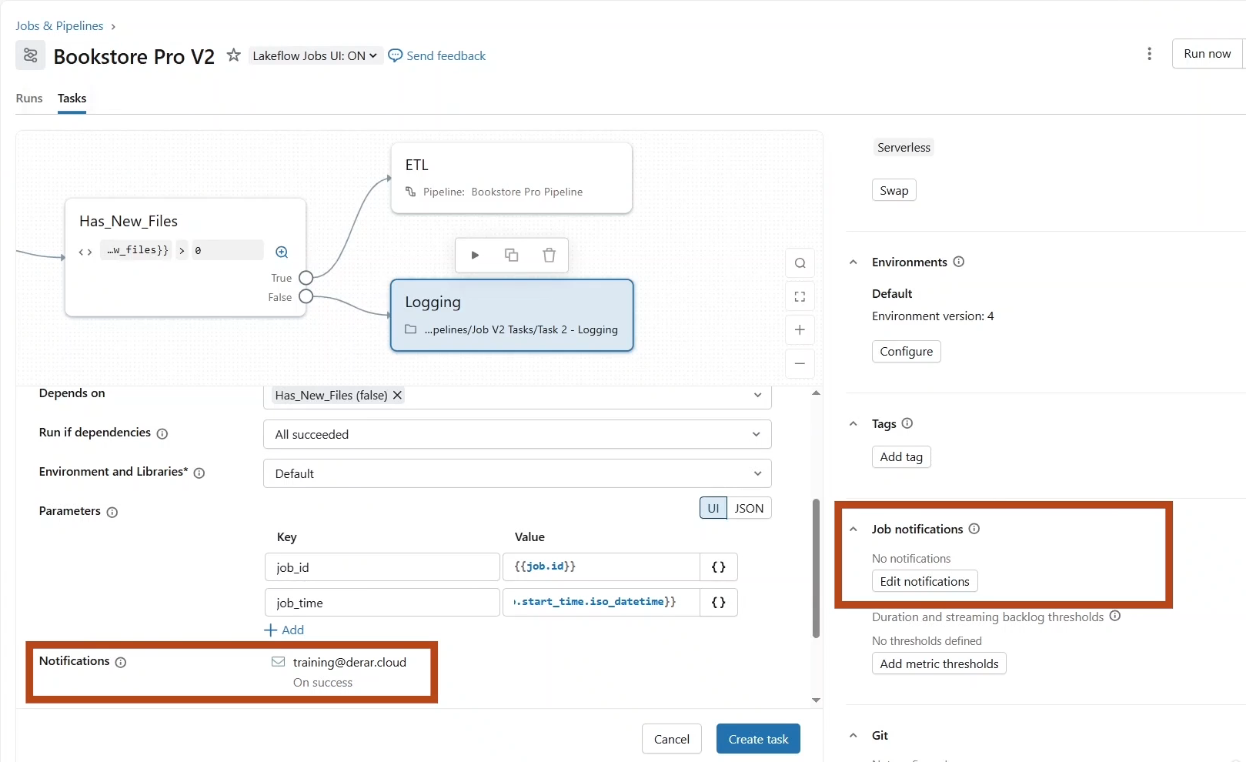

* Let us **create this task**.
* Next, after running our ETL pipeline, we want to add a notebook task to get the table list created by the pipeline.

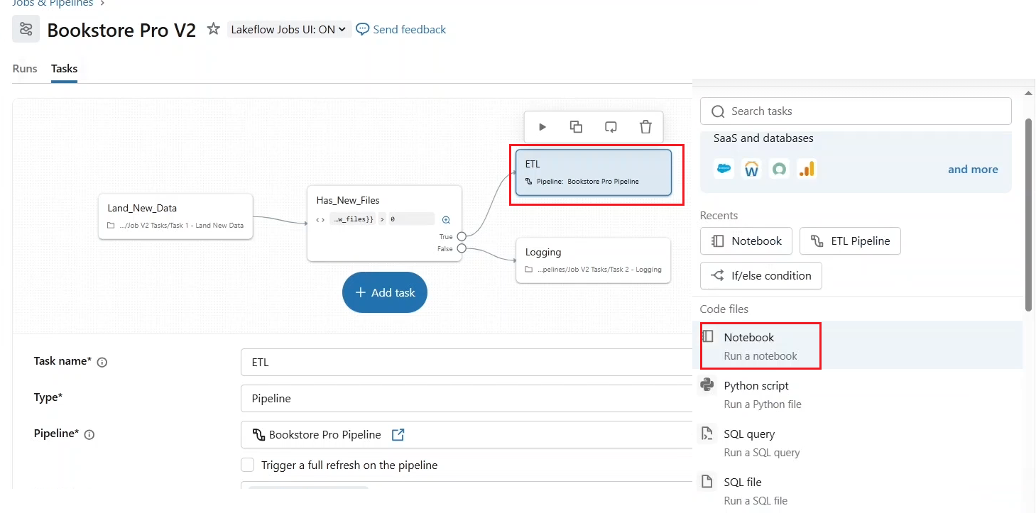

* + Task name list tables for path.
  + We are going to select the **List Tables notebook** from the job v2 folder.

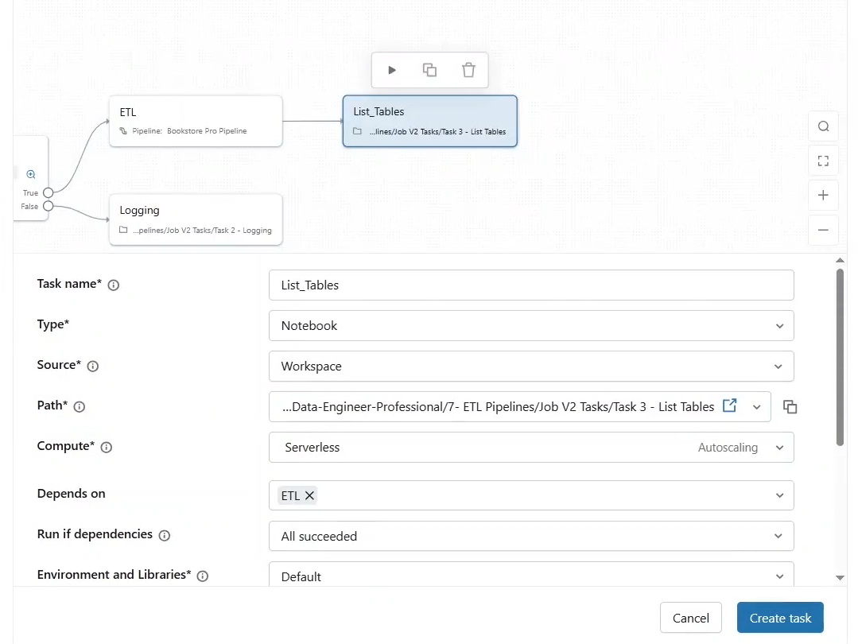

* + Let us look at this notebook. This notebook leverages the system Catalog to get the tables of a given data Catalog and schema that we pass as a parameter to this notebook.
  + In the system Catalog we have the information schema.This schema provides information about objects across all data Catalogs within the Metastore, such as the list of reviews, volumes, and tables.
  + This query here lists the tables created by our pipeline, showing the table name and its type, whether it is a streaming table or a materialized view.
  + And we return the resulting array as a task value to pass it later for a for each task.

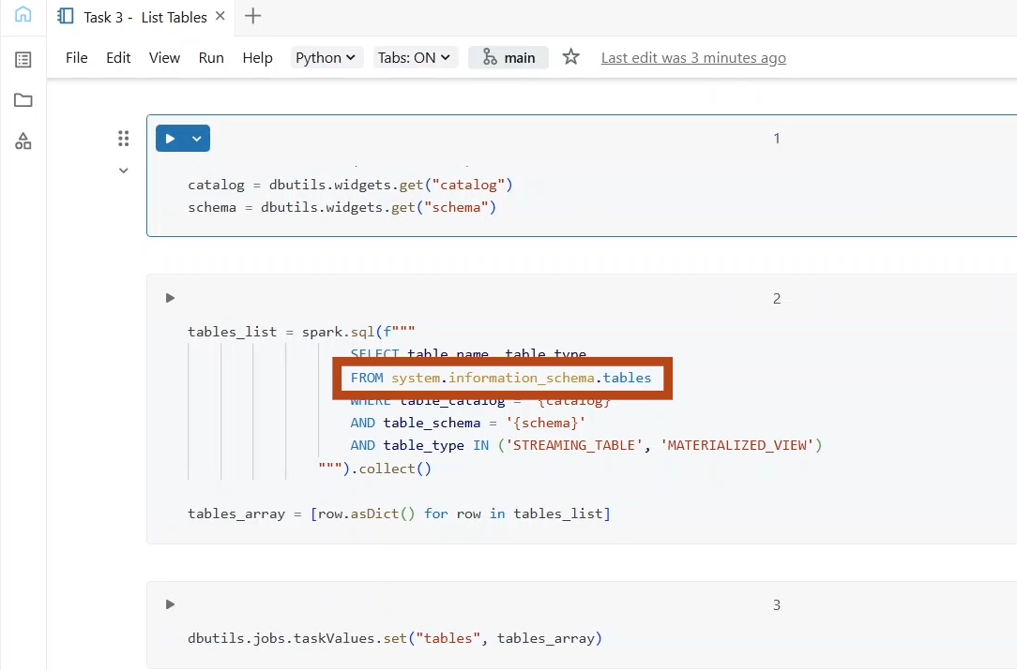

* + For now, let us come back to our **job configuration** and set the input parameters Catalog and schema.
  + We can define these as **Task parameters** as usual, but as I am planning to use them in other tasks as well, it is better to define them as **Job parameters** instead.

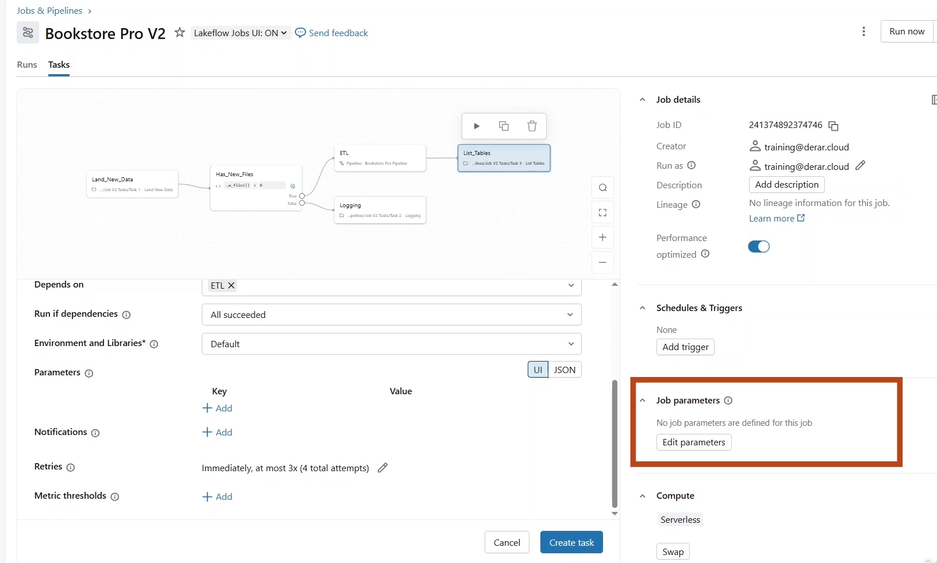

* + Let us first finalize creating this task.

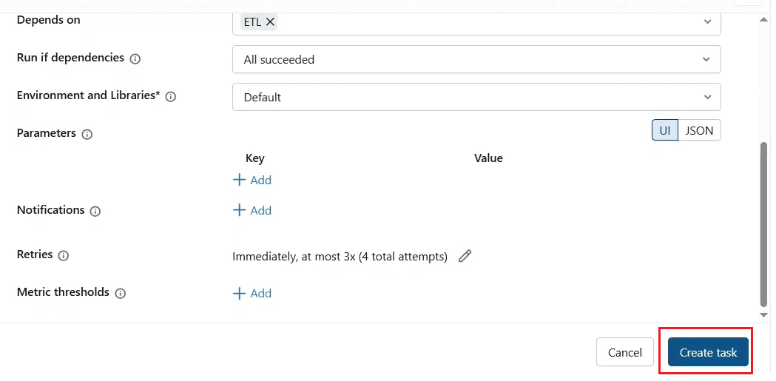

* + And now click **Edit Parameters** under **Job Parameters** in the right panel. Provide, here the name of your Catalog and the default schema of your ETL pipeline and click save.

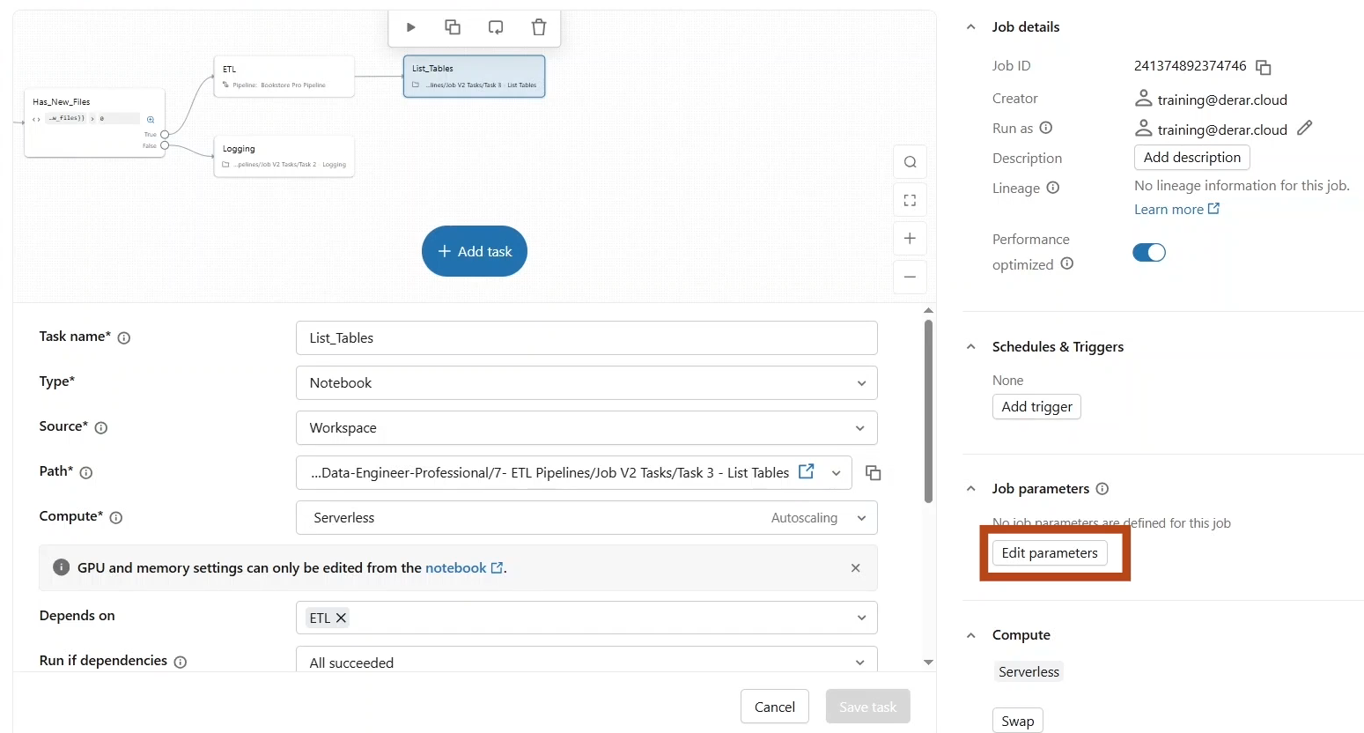

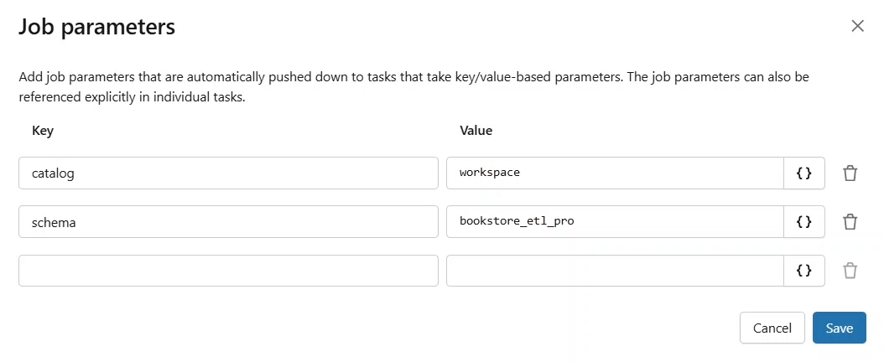

* + Parameters are automatically pushed down to all tasks. So, if you have a task parameter with the same name, it will be automatically overridden by the job parameter.

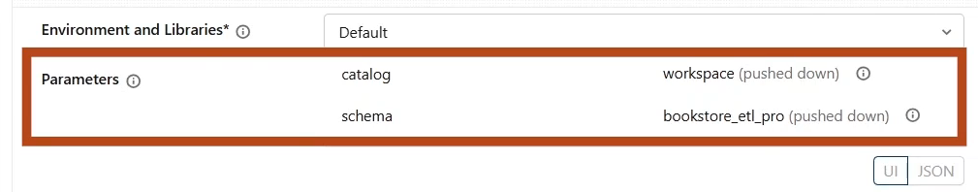

* + Lastly, let us add a task of type **for each** loop to iterate over each item in the tables array using a nested notebook.

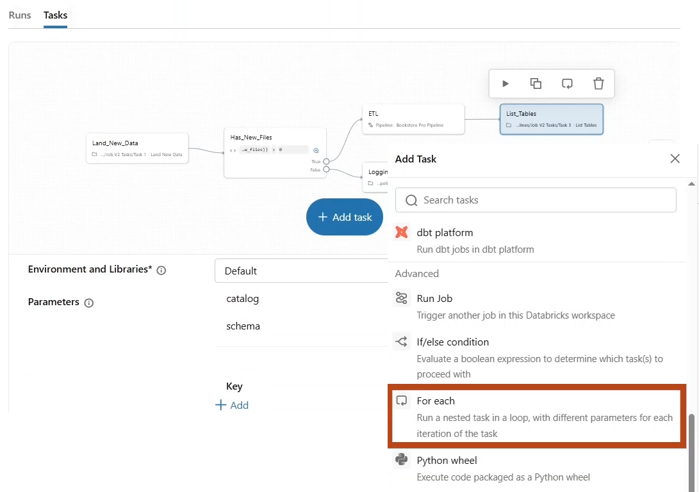

* + Task name tables iterator. Where the input is the task value, name it tables representing the array returned from the list table notebook. Here we can also set the concurrency level to run multiple iterations in parallel.

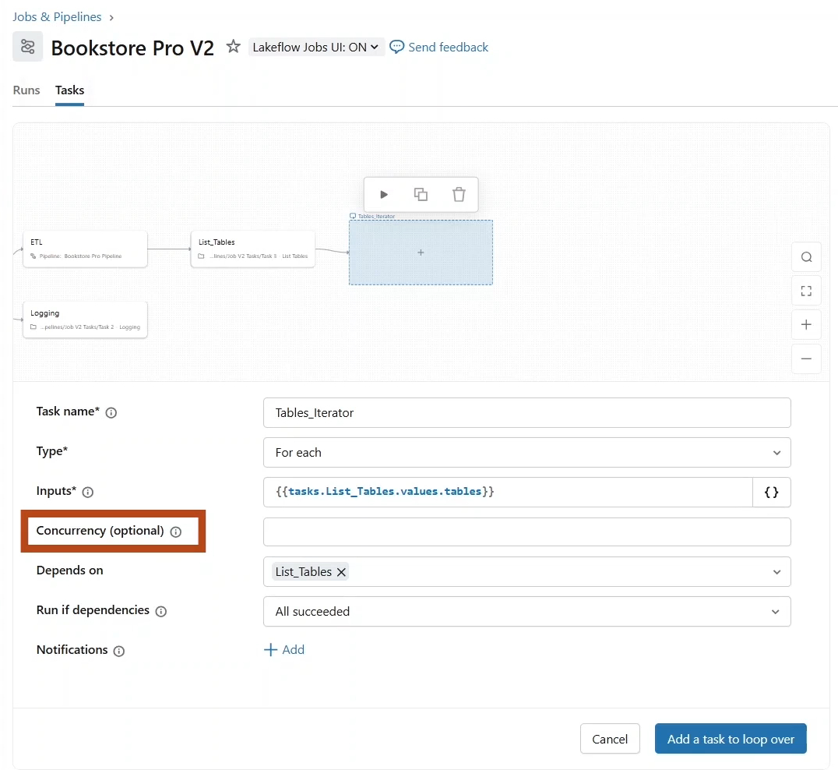

* + Now click this **+** button or inside the iterator to configure the **nested task**, which is a notebook task that will analyse each table also click on “Add a task to loop over”.

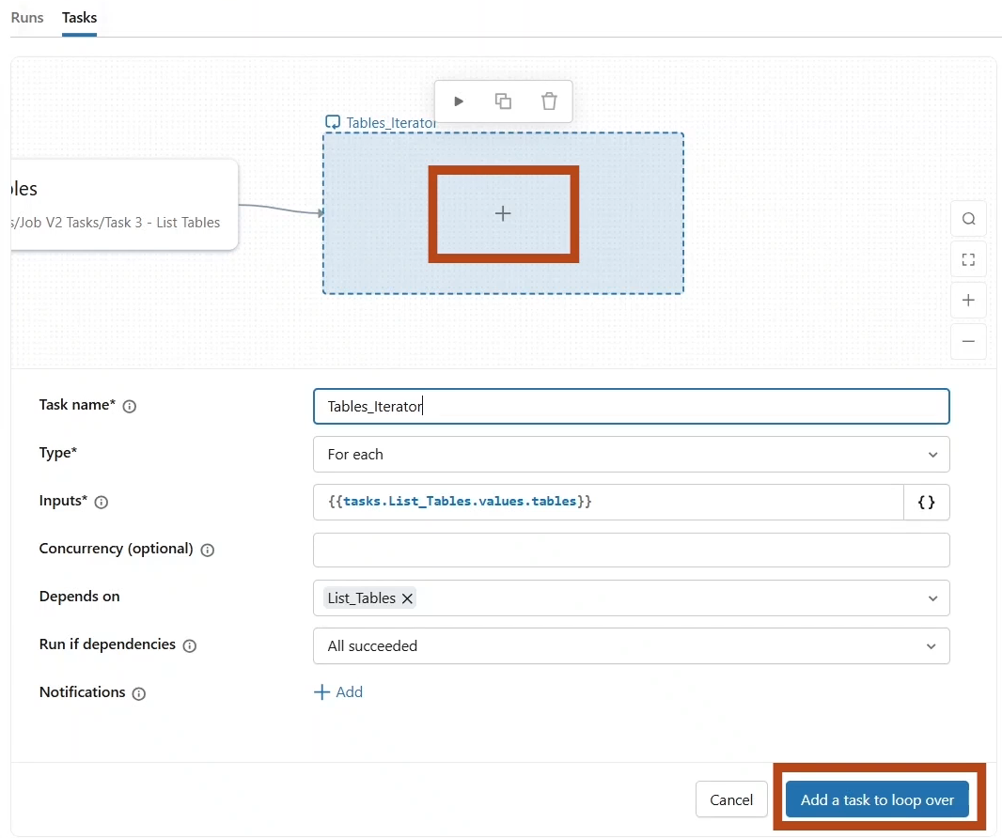

* + - Task name “Analysis_iteration”.
    - Type notebook for path. We are going to select the **Analyze Table** notebook from the job v2 folder.

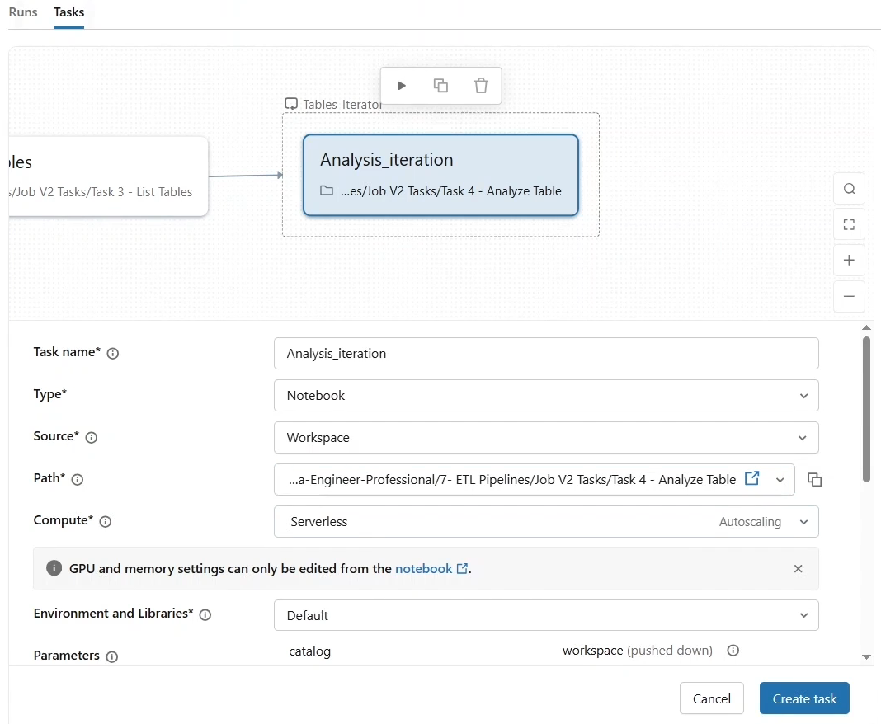

* + - Let us look at this notebook.
    - This notebook provides a simple analysis of a given table by printing its name, type, records, counts, and sample data.
    - And as you can see, we provide the Catalog schema, table name, and type as input parameters.

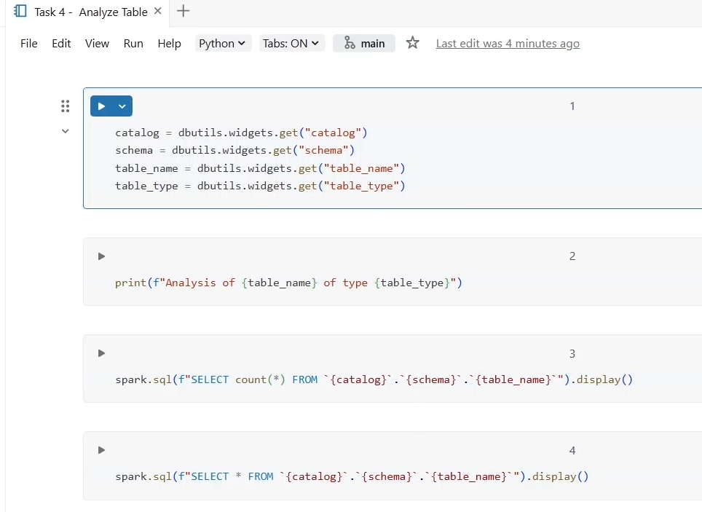

* + - Let us come back to our job configuration and set these parameters.
    - As you can see, the Catalog and schema parameters are already passed to the task as job parameters.

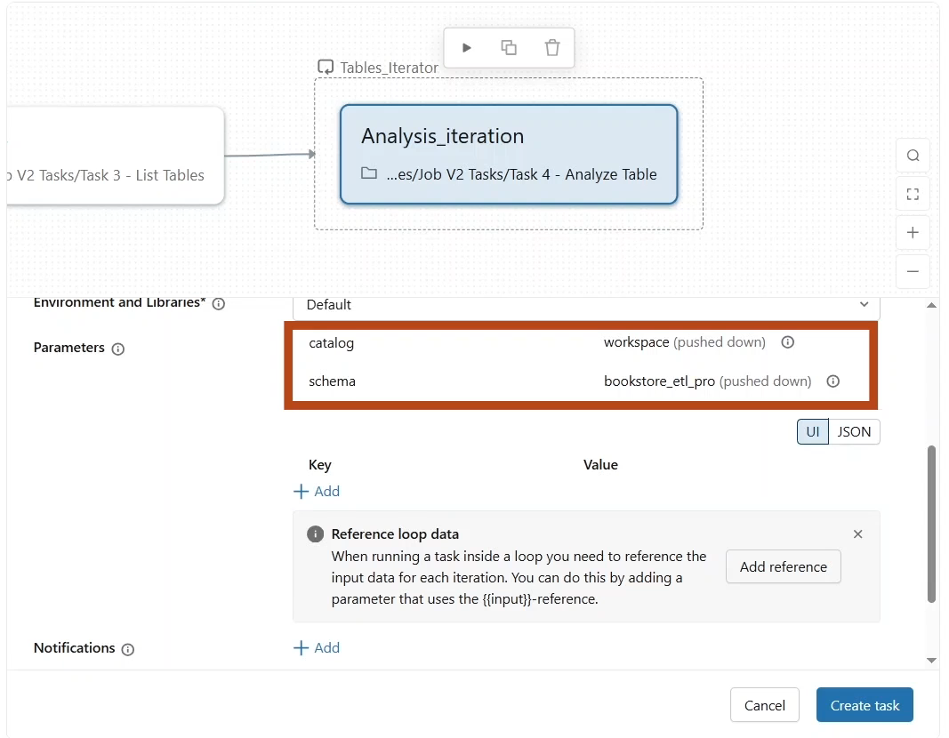

* + - So, we just need to add the **table name** and **table type**.
    - Let us start by the table name to reference the input array passed from the foreach iterator. We use the input reference followed by the individual object field. For example, table name as defined in our list tables notebook. Similarly, let us add the table type parameter.

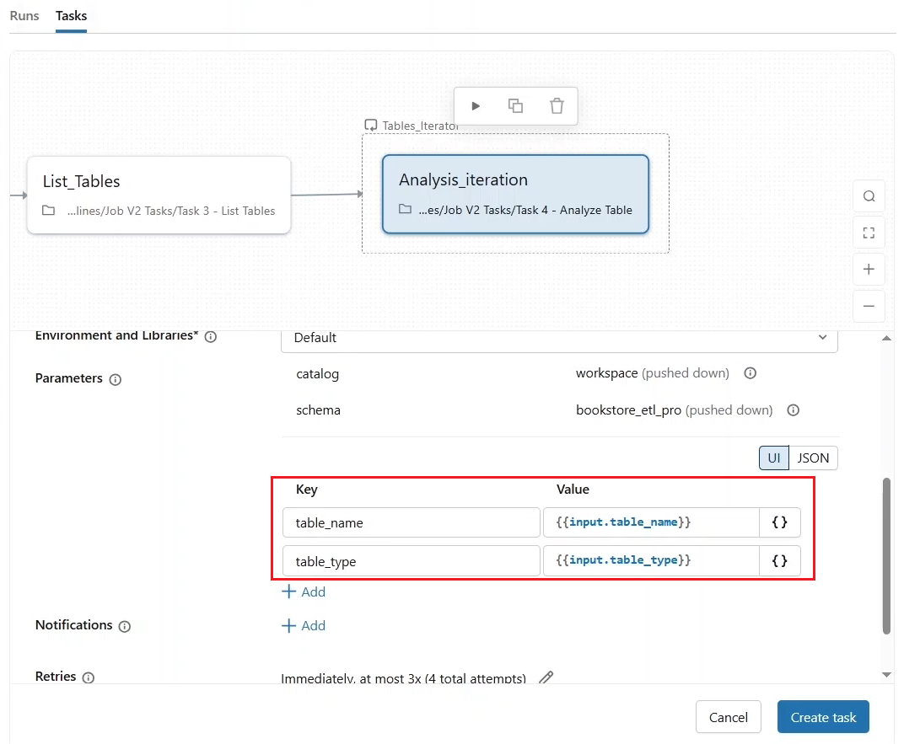

* + - And click **create task**.
* Let us now proceed with running this job.

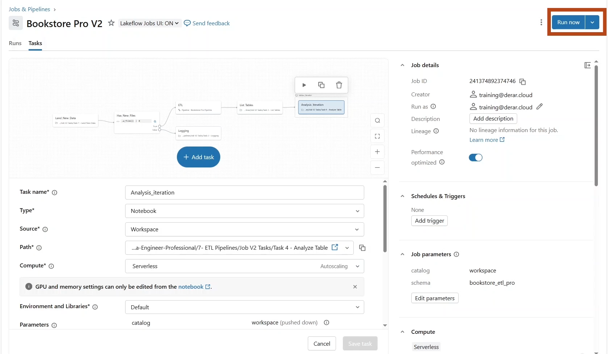

* Great new data files were landed evaluating the if else condition to true, which triggers a pipeline update.

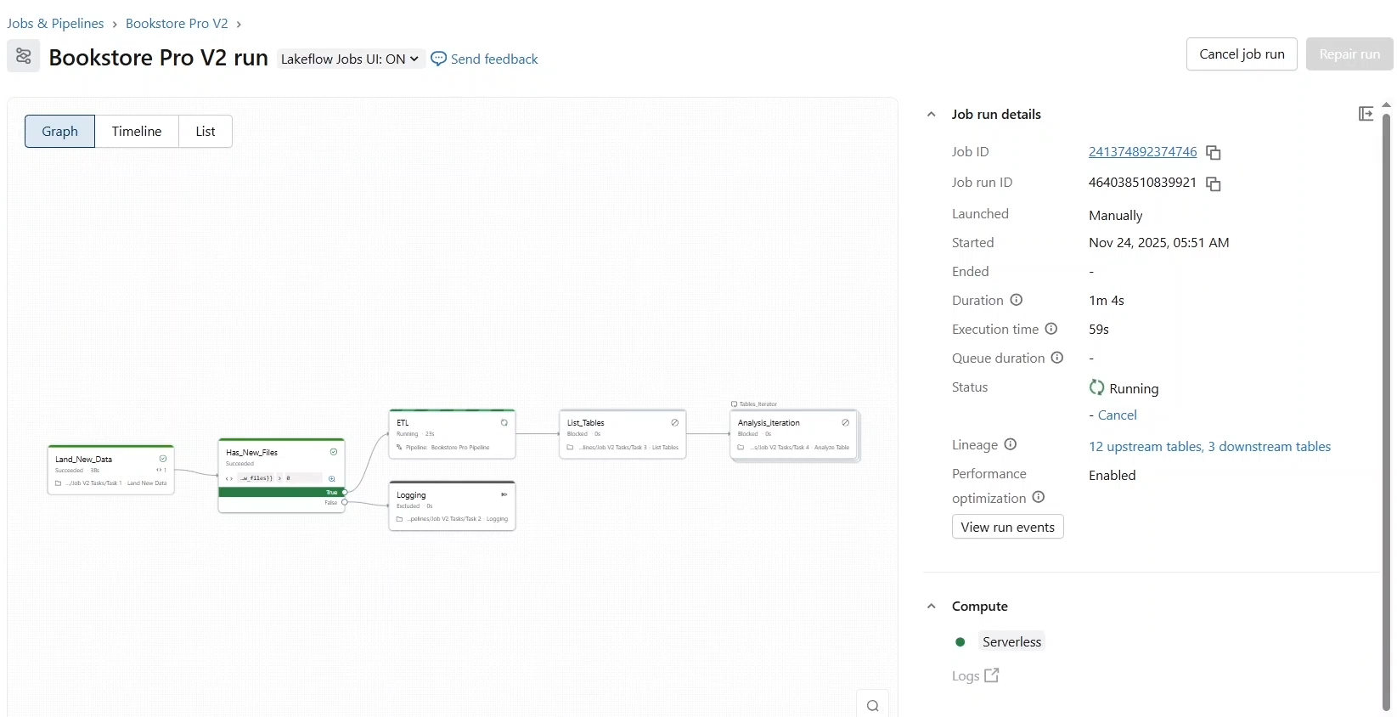

* Next, we listed the created tables and passed them to the for each task.
* If we open the “**Analysis_Iteration**” task. We can see the run of the nested notebook tasks for each table.

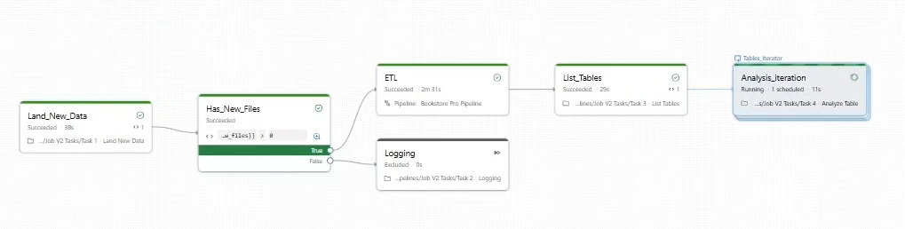

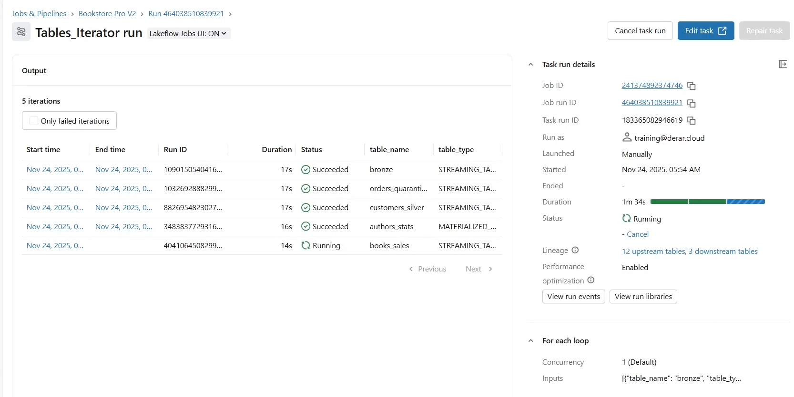

* The job has been successfully executed.

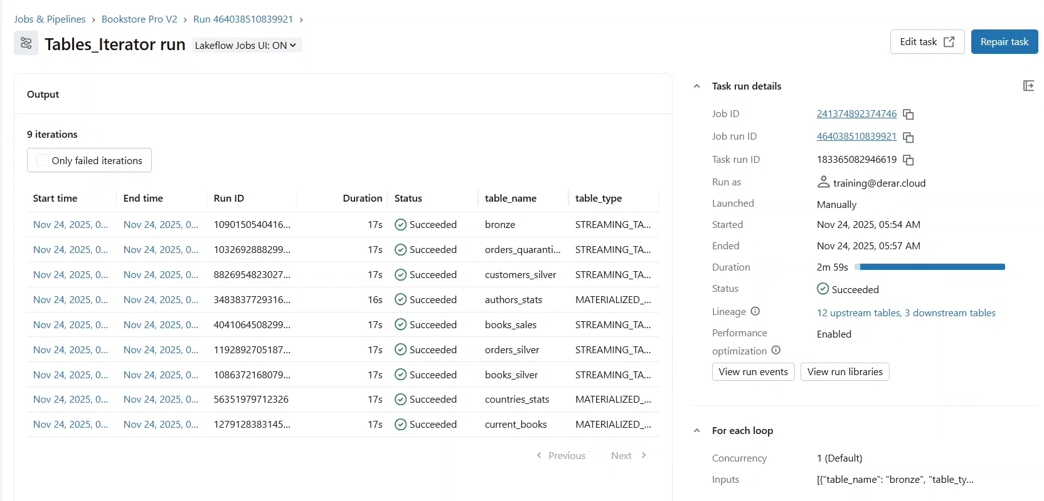

* Let us end up by exploring what happens if we have an undefined parameter, say the **schema parameter** is missing.

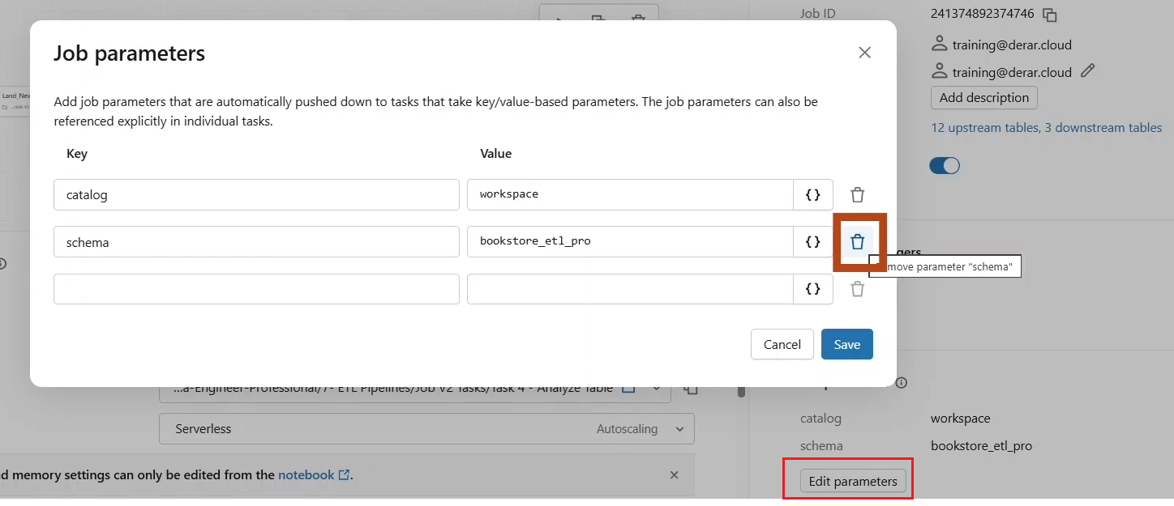

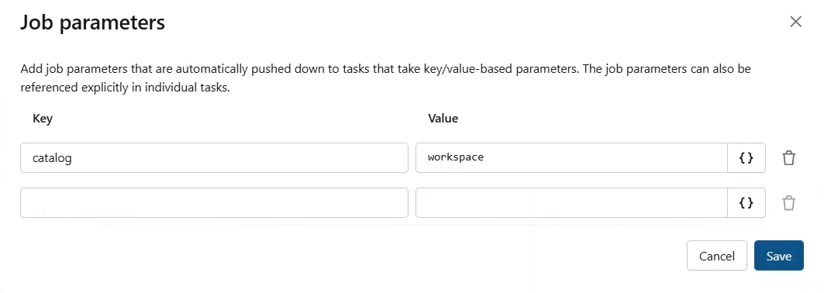

* Let us run the job via clicking on “**Run Now**” button.
* As you can see, we got an error because of the missing schema parameter.

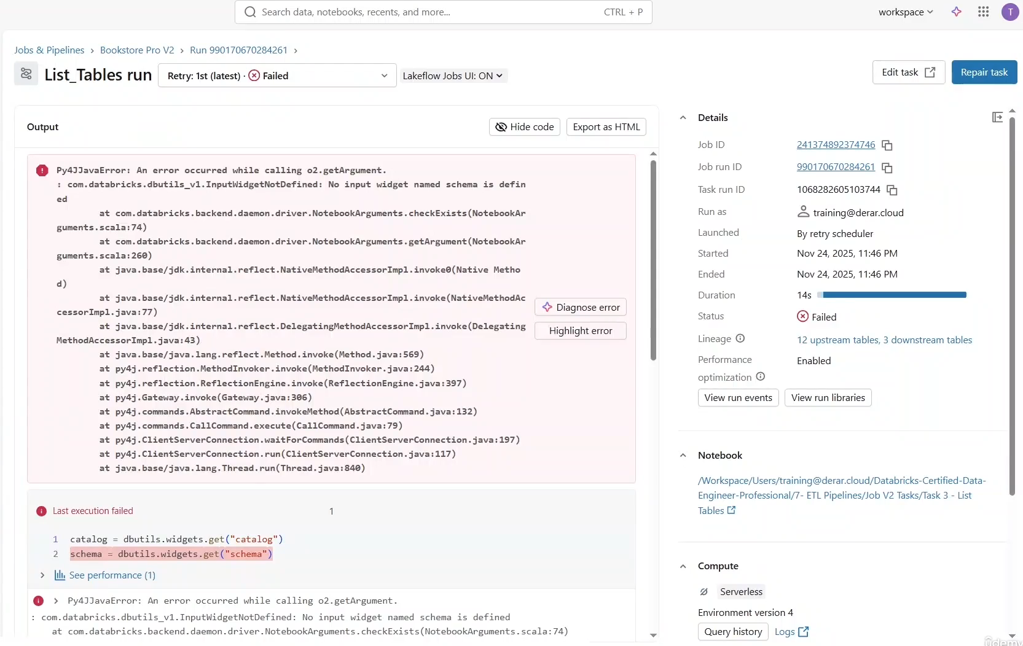

* If you click **Repair Run**, you see that you have the option to update or add any job level parameter.
* So let us add the schema parameter for this run and click **Repair Run**.

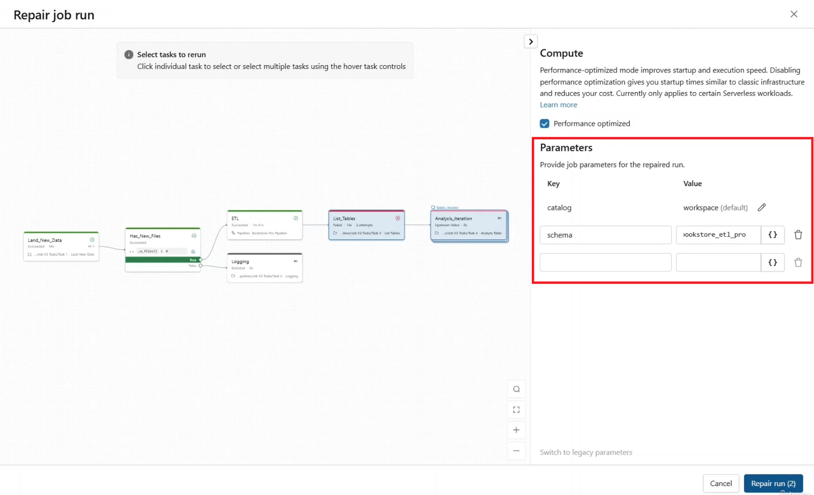

* The job has been successfully executed.
* Of course, that was a quick fix for this run, but we still need to update the job configuration and include the missing parameter to avoid similar issues with the future runs.